Guided Reading
Tuesday 26th January 2021
Read the next 2 pages of the Lion, the Witch and the Wardrobe and then answer the questions below.
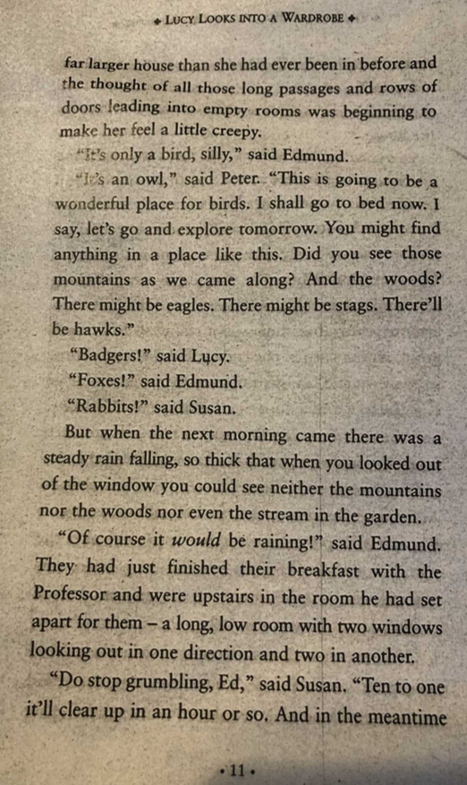

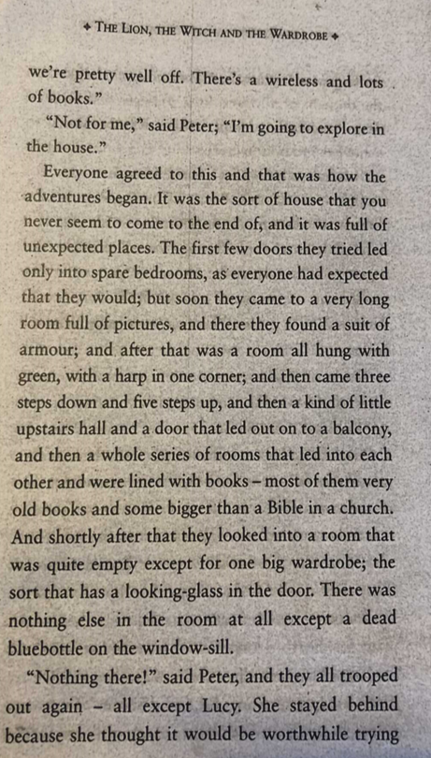

We are learning to apply our inference skills.

1. Can you write the definition for the idiom or word?
Can you create a sentence? Can you think of a synonym? (Vocabulary)

trooped
passages
wireless
pretty well off

2. Why do you think Edmund said, 'Of course it would be raining!'? Explain your answer referring to the text.

3. What kind of atmosphere has the author created, on page 11 and 12? How have they achieved this?

4. How does the author emphasis the size of the house?

