Guided Reading
Wednesday 27th January 2021
Read the next 2 pages of the Lion, the Witch and the Wardrobe and then answer the questions below.
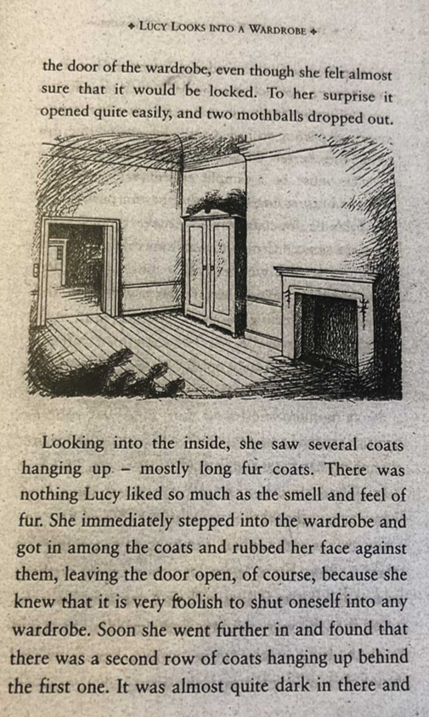

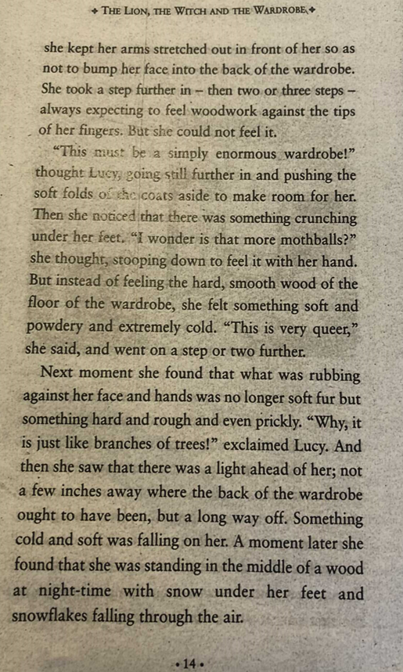

We are learning to apply our inference skills.

1. Can you write the definition for the idiom or word?
Can you create a sentence? Can you think of a synonym? (Vocabulary)

queer
stooping
mothball
ought

2. Why do you think the author describes the mothballs dropping out of the wardrobe? What does that tell us?

3. Why do you think Lucy went into the wardrobe? Use evidence from the text to back-up your answer.

4. Write 4 adjectives, with your reasons, to describe how Lucy was feeling as she moved through the wardrobe.

5. What did Lucy mean when she used the phrase, 'This is very queer'?

