Guided Reading
Thursday 28th January 2021
Read the last 2 pages of chapter 1 from the Lion, the Witch and the Wardrobe and then answer the questions below.
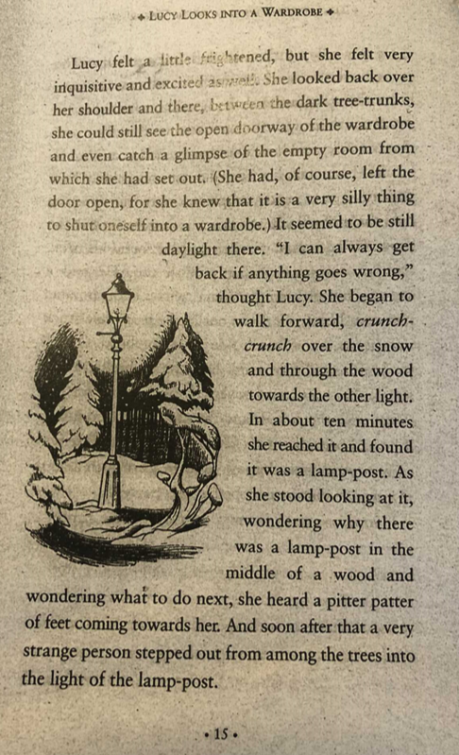

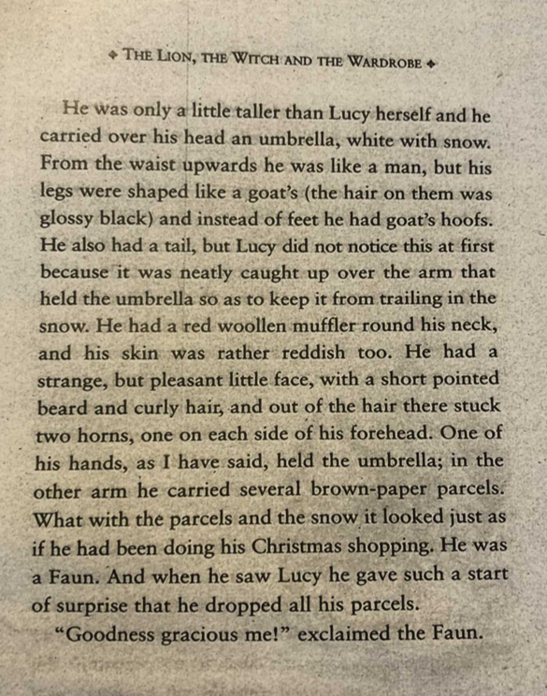

We are learning to apply our inference skills.

1. Can you write the definition for the idiom or word?
Can you create a sentence? Can you think of a synonym? (Vocabulary)

inquisitive
glimpse
trailing
pleasant

1. Why do you think Lucy did not turn back and go back to the house? Use evidence from the text to support your views.

2. How does the author's description of the Faun make him seem strange or different?

3. Why do you think the Faun says, 'Good gracious me!'?

4. How do you think you would have felt if you were standing in that world instead of Lucy? Why would you feel this way?

