Wednesday 27th January 2021

Please remember that learning through play is just as valuable as lesson time. Periods of time are encouraged to be set aside for the children to enjoy learning through play and their choice. Also try not to put too much pressure on yourselves, learning is everywhere.

You can download lots of eBooks from Oxford Owl. The link is below

https://www.oxfordowl.co.uk/for-home/find-a-book/library-page/

Phonics

Today we are going to learn to read, write and spell with the or sound (shut the door.
Spellings to write 3 times: short, worn, snort
Sentence: I can eat with a fork Or I eat my lunch with a fork .

Phonics link: https://youtu.be/1Og7aS17Z44

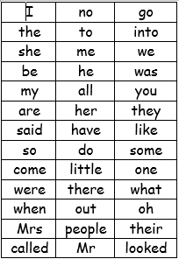
We have learned up to they and said on the red word list.

Redwords
https://www.bbc.co.uk/bitesize/topics/zf2yf4j/articles/zdrd8xs

A useful site for letter formation
https://www.doorwayonline.org.uk/activities/letterformation/

ar sound lesson with RWI
https://www.youtube.com/watch?v=7NPAgQhdKN4

Story
Trumpety Trump!
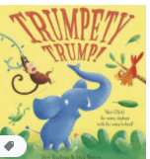

https://youtu.be/utHyWOty6kM

Topic
This week we will be learning more about Earth.
Sea pollution
https://www.youtube.com/watch?v=bGWr5jXJfbs
Talk about ways in which we can help keep the seas pollution free.
Physical
A bit of dancing to liven us up today.
https://www.bbc.co.uk/iplayer/episode/m000jsf1/otis-boogie-beebies-series-1-1-zoom-to-the-moon

Reading

Please try to read daily. I have added a few different places to access books below if required. eggs are doing a 30day free trial.
https://readingeggs.co.uk/gaw/branded?gclid=Cj0KCQiA0rSABhDlARIsAJtjfCdhZWSyB-XUErpy6aNiKuscgQq9_ggwTQ_j4hCj3PF83-MIB1NkusgaAp2HEALw_wc
Oxford Owl eBooks
https://www.oxfordowl.co.uk/for-home/find-a-book/library-page/
Blending book:
https://www.oxfordowl.co.uk/api/interactives/29253.html
3 red ditty books in 1 book
https://www.oxfordowl.co.uk/api/interactives/24766.html

Maths today
Still comparing
https://whiterosemaths.com/homelearning/early-years/week-2/
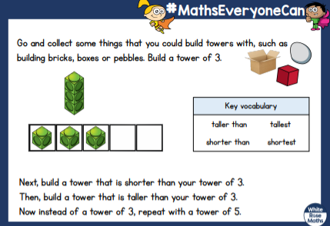
Use Mathletics to support your math’s further.

Creative
Can you make a sea creature craft with items that would normally go in the bin?
