Thursday 28th January 2021

Please remember that learning through play is just as valuable as lesson time. Periods of time are encouraged to be set aside for the children to enjoy learning through play and their choice. Also try not to put too much pressure on yourselves, learning is everywhere.

You can download lots of eBooks from Oxford Owl. The link is below

https://www.oxfordowl.co.uk/for-home/find-a-book/library-page/

Phonics

Today we are going to learn to read, write and spell with the air sound (that’s not fair).
Spellings to write 3 times: stair, chair, hair.
Sentence: I sat on the chair Or I have very long dark hair

Phonics link: https://youtu.be/RJv5wgbJNxE

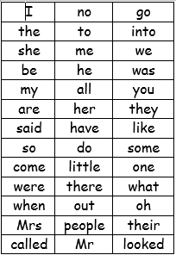
We have learned up to they and said on the red word list.

Redwords
https://www.bbc.co.uk/bitesize/topics/zf2yf4j/articles/zdrd8xs

bang game ( red word) handout on the blog.

A useful site for letter formation
https://www.doorwayonline.org.uk/activities/letterformation/
air sound lesson with RWI
https://www.youtube.com/watch?v=rwLEjJ50LfY

Learning to read at home with Read Write Inc. Phonics during School Closure
Daily lessons for children are available from 9.30am. Phonics lessons on Facebook and YouTube for children to watch at home.
Please note: the films are streamed live and won’t be available at other times.

Story
https://www.youtube.com/watch?v=2qjgUPUiZXM

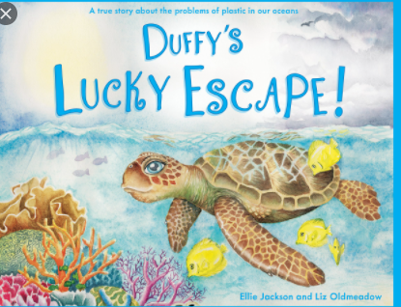
Can you write a sentence to Duffy telling him about the dangers of plastic pollution?

Physical
Sea yoga
https://www.youtube.com/watch?v=BrYqWAw8P_8

Reading

Please try to read daily. I have added a few different places to access books below if required. eggs are doing a 30day free trial.
https://readingeggs.co.uk/gaw/branded?gclid=Cj0KCQiA0rSABhDlARIsAJtjfCdhZWSyB-XUErpy6aNiKuscgQq9_ggwTQ_j4hCj3PF83-MIB1NkusgaAp2HEALw_wc
Oxford Owl eBooks
https://www.oxfordowl.co.uk/for-home/find-a-book/library-page/
Blending book:
https://www.oxfordowl.co.uk/api/interactives/29253.html
3 red ditty books in 1 book
https://www.oxfordowl.co.uk/api/interactives/24766.html

Maths today
Still comparing but this time length
https://whiterosemaths.com/homelearning/early-years/week-2/
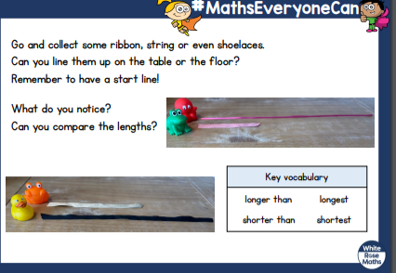
Use Mathletics to support your math’s further.

Creative
There is a handout on the blog in case you want to use it.
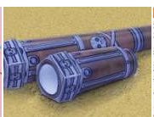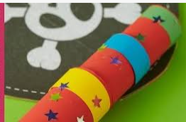
Or you can watch the link https://www.pinterest.co.uk/pin/247768416980269513/ and make your own.
Can you use your telescope to spot plastic that needs to be recycled and help Duffy to keep safe?
Mind fullness
Draw around your hand a write down what you have enjoyed this week. List your friends or favourite things. You could even make a friendship bracelet.
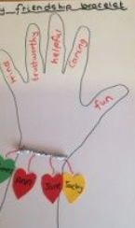

The assembly fits in nicely with today.
https://www.stcleerprimary.co.uk/Blog/Heads-Blog

