Friday 29th January 2021

Please remember that learning through play is just as valuable as lesson time. Periods of time are encouraged to be set aside for the children to enjoy learning through play and their choice. Also try not to put too much pressure on yourselves, learning is everywhere.

You can download lots of eBooks from Oxford Owl. The link is below

https://www.oxfordowl.co.uk/for-home/find-a-book/library-page/

Phonics

Today is slightly different, we are going to practise with the ay, ee, igh sounds. There is a worksheet on the blog.

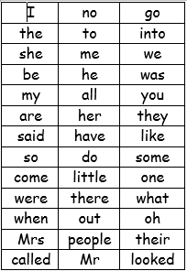
We have learned up to they and said on the red word list.

Redwords
https://www.bbc.co.uk/bitesize/topics/zf2yf4j/articles/zdrd8xs

bang game ( red word) handout on Thursdays blog page.

A useful site for letter formation
https://www.doorwayonline.org.uk/activities/letterformation/
air sound lesson with RWI
https://www.youtube.com/watch?v=rwLEjJ50LfY
Read Write Inc Lessons
https://www.youtube.com/channel/UCo7fbLgY2oA_cFCIg9GdxtQ

Story
https://www.youtube.com/watch?v=cPPQdDwTUvE

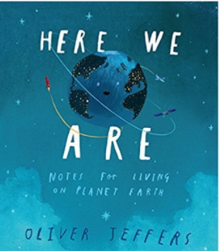
Or
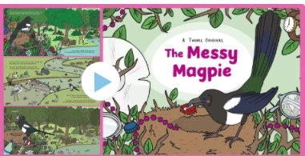
Link on the blog page.

Feel Fit Friday
https://www.youtube.com/watch?v=aZru-M3TUlI Sonic Boom workout .
Or you can decide on your own fitness regime today/perhaps go outside for a run/ kick a football etc..

Reading

Please try to read daily. I have added a few different places to access books below if required. eggs are doing a 30day free trial.
https://readingeggs.co.uk/gaw/branded?gclid=Cj0KCQiA0rSABhDlARIsAJtjfCdhZWSyB-XUErpy6aNiKuscgQq9_ggwTQ_j4hCj3PF83-MIB1NkusgaAp2HEALw_wc
Oxford Owl eBooks
https://www.oxfordowl.co.uk/for-home/find-a-book/library-page/
Blending book:
https://www.oxfordowl.co.uk/api/interactives/29253.html
3 red ditty books in 1 book
https://www.oxfordowl.co.uk/api/interactives/24766.html

https://www.youtube.com/playlist?list=PLDe74j1F52zSd85pobSCXJmhnHbJ4pggB

Maths today
Still comparing but this time size
https://whiterosemaths.com/homelearning/early-years/week-2/
session 5
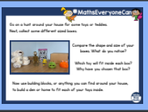
Use Mathletics to support your math’s further.

Mind fullness
Wellbeing.
Rainbow fish colouring

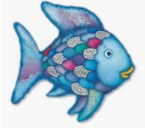
Pom Pom treat
https://www.youtube.com/watch?v=Fonk8Dc3MbE
In this Earth Day special, the Octonauts are protecting endangered coral reefs! Come and learn about all sea life including fish, sharks, whales and more!

Topic
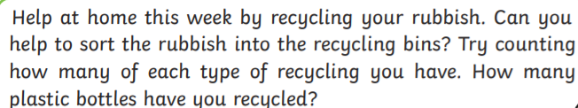
you could even put a photograph on Tapestry of all your recycled rubbish.

