Monday 1st February 2021

Please remember that learning through play is just as valuable as lesson time. Periods of time are encouraged to be set aside for the children to enjoy learning through play and their choice. Also try not to put too much pressure on yourselves, learning is everywhere.

You can download lots of eBooks from Oxford Owl. The link is below

https://www.oxfordowl.co.uk/for-home/find-a-book/library-page/

Phonics

Today we are going to revise the oo (look at a book sound and practise to spell , read and write with the oo sound.
Phonics link
https://youtu.be/1OO8vt7cnGw
Spellings: cook, foot, book
Sentence I can look at a book or I took a big cook book of the shelf.
Red words- have , like

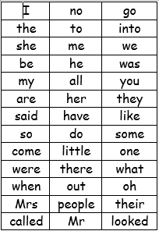
We have learned up to they and said on the red word list. This week we are learning have and like.

Redwords
https://www.bbc.co.uk/bitesize/topics/zf2yf4j/articles/zdrd8xs

bang game ( red word) handout on Thursdays blog page.

A useful site for letter formation
https://www.doorwayonline.org.uk/activities/letterformation/
Set 2 sound lesson with RWI
https://www.youtube.com/watch?v=p7hRbrpq5Bo
Read Write Inc Lessons
https://www.youtube.com/channel/UCo7fbLgY2oA_cFCIg9GdxtQ

Story
Ronald the rhino
https://youtu.be/ZrB8itwwQEQ
Who is the mystery animal that Leopard and Python are describing?
How did Ronald feel when he saw himself in the water?
Who is the mystery animal that Leopard and Python are describing?
Which animal would you like to be like out of the story? Why?

Physical
Mr Jones aimed at all levels
https://youtube.com/watch?v=cdX6N3GcWxk&feature=share
or go outside and on a scavenger hunt.
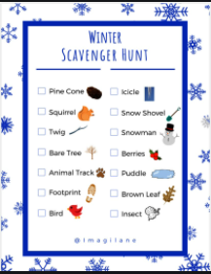

Reading

Please try to read daily. I have added a few different places to access books below if required. eggs are doing a 30day free trial.
https://readingeggs.co.uk/gaw/branded?gclid=Cj0KCQiA0rSABhDlARIsAJtjfCdhZWSyB-XUErpy6aNiKuscgQq9_ggwTQ_j4hCj3PF83-MIB1NkusgaAp2HEALw_wc
Oxford Owl eBooks
https://www.oxfordowl.co.uk/for-home/find-a-book/library-page/
Blending book:
https://www.oxfordowl.co.uk/api/interactives/29253.html
3 red ditty books in 1 book
https://www.oxfordowl.co.uk/api/interactives/24766.html

Maths today
Looking at the numbers 6, 7 &8 and then pairs.
https://whiterosemaths.com/homelearning/early-years/growing-6-7-8-week-2/
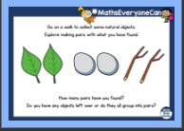
Use Mathletics to support your math’s further.

Mind fullness.
Smiling challenge, draw a huge smiling face and then write down all the reasons that you smile.

Topic
This week we are going to look at what lives on earth.
Today we are looking at habitats;
https://www.youtube.com/watch?v=ZrSWYE37MJs
The challenge today is doing some of your own research
can you find 5 animals that live in different parts of the world and name their habitat? (some help on the blog page.)
Can you find 3 animals that live in the dessert

