Tuesday 2nd February 2021

I am trying to cut down on computer time today.

Phonics

Today we are going to revise the oo (poo at the zoo) sound and practise to spell, read and write with the oo sound.
Phonics link:
https://youtu.be/2bLxQwTfuiw

Spellings: moon, spoon, pool
Sentence I can see a pool or The moon is high and bright at night.
Red words- have , like

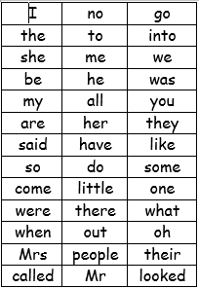
We have learned up to they and said on the red word list. This week we are learning have and like.

Story
Sit comfortably outside, or even make a den and read a page or two of your favourite book.
Reading
Please read with your grown up once today.

Physical

Chalk wavy, curved or zig zag lines outside and get the child to follow the pattern when walking, running, hopping, skipping, jumping or whilst riding a bike.
Or
Run for 3 minutes and star jump on the spot for 1 minute. How many jumps can you do in a minute?

Maths today
https://whiterosemaths.com/homelearning/early-years/growing-6-7-8-week-2/
Looking at the numbers 6, 7 &8 and combining 2 groups .
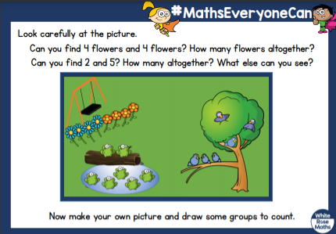
Mind fullness.
Listen to your favourite music and draw anything you want to today.
Sentence
I have attached a sentence a day on the blog today can you please write a sentence to go with Tuesday’s picture? Ie: I can see a sunset etc...
Topic
We are still looking at the world and incorporating animal’s habitats in the rainforest.
I have attached a rainforest map on the blog.
https://www.youtube.com/watch?v=KMdD6TTDZ_g

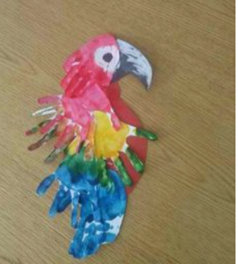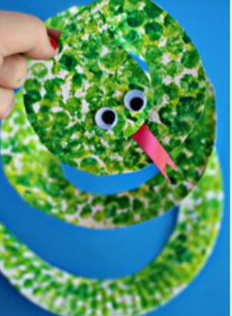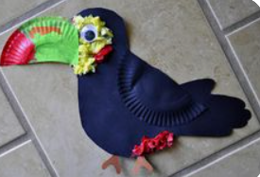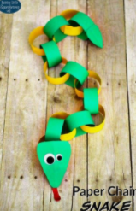
I have also attached a raincloud science actvity on the blog page.

