Wednesday 3rd February 2021

A message posted on Tapestry today.
Hi everyone, I know the children are missing each other and I really want to do something to spread a little happiness. I was wondering about co-ordinating a story, something easy that the children know like "we are going on a bear hunt". My idea is that the children each video themselves saying a line of the story and send it to me via Tapestry. I will (finger crossed) then collate it and send it out via Tapestry or a you tube link. All the videos would need to be landscape. At least this way the children get to see each other and can watch it as many times as they like.
If you would like to be part of this , please can you like this post by Thursday and I will send you, your part .
Thank you .

I am still trying to cut down on computer time today.

Phonics

Today we are going to revise the ow (blow the snow) sound and practise to spell, read and write with the ow sound.
Phonics link:

Spellings: blow, snow, flow, glow
Sentence: I can blow the snow or I blow the snow high into the air.
Red words- have, like

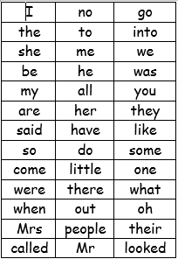
We have learned up to they and said on the red word list. This week we are learning have and like.

Story.

Find a few teddy bears or a few puppets and read a story of your own choice together. You could pretend to be the teacher, read in your bedroom, under a table etc..

Reading
Please read with your grown up once today.

Physical
A 5minute pulse racer with Mr Jones
https://youtu.be/pu0Xb5vCwA
or
have a disco with your family and dance to your favourite tunes.
Maths today
https://whiterosemaths.com/homelearning/early-years/growing-6-7-8-week-2/
session 4 Looking at the numbers 6, 7 &8
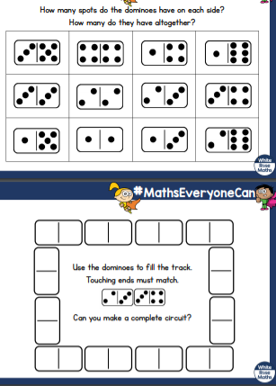
Mind fullness.
Write a letter of card to someone to say hello.
Topic
We are still looking at the world and habitats on earth.
There is a power point on the blog page. Today could you design and then go outside and make you own animal habitat? It could be for a bird/ mouse/ badger etc.

