Thursday 4th February 2021
I am still trying to cut down on computer time today.

Phonics

Today we are going to revise the igh (fly high) sound and practise to spell, read and write with the igh sound.
Phonics link: https://youtu.be/8fxn5a1t0Tc
Spellings: bright, flight, night, light
Sentence: The sun is bright or The sun is big and bright at night.
Red words- have, like

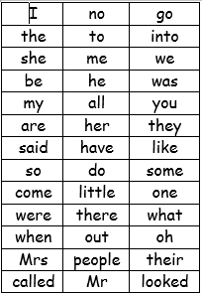
We have learned up to they and said on the red word list. This week we are learning have and like.

Story.
Why not try to recreate a story or make up your own story today.
How will it start?
What happens in the middle part of your story?
How will it end?
How many characters will you have?
Will they be nice characters?
What will they do/go etc..

Reading
Please read with your grown up once today.

Physical yoga
make up your own fitness routine, Jo Wicks style.
I will also add some yoga cards on the blog as another option.
Or
Go outside and ride your bike or scooter.

Maths today
Session 5
https://whiterosemaths.com/homelearning/early-years/growing-6-7-8-week-2/
https://vimeo.com/500529845
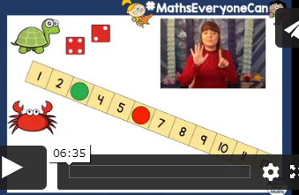
session 4 Looking at the numbers 6, 7 &8
Mind fullness.
Paint a pebble and then give it to someone in your house and tell them why you appreciate them.
Topic
We are still looking at the world and habitats on earth. Today though we are looking at insect’s habitats. Power point and hand out on the blog.

Diary dates (we will touch on these over the course of the next 2 weeks)
12th Feb Chinese New Year
!4th Feb –Valentines
16th Feb- Chinese New Year
14th March Mother’s day.

