Friday 5th February 2021
I am still trying to cut down on computer time today.

Assembly. Express yourselves
https://www.youtube.com/watch?v=zslH2Ld3mQM&feature=youtu.be

Phonics

Today we are going to revise the ee (what can I see) sound and practise to spell, read and write with the ee sound.
Phonics link:
https://youtu.be/qRJ6ZhoWZ0Y
Spellings: see, sleep, three, keep
Sentence: I can see the sheep. or The green tree is big and high.
Red words- have, like

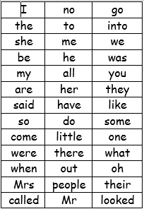
We have learned up to they and said on the red word list. This week we are learning have and like.

Story.
Use puppets/toys to act out and tell a story together.

Reading
Please read with your grown up once today.

Physical
Go on a mini beast hunt (sheet attached on the blog)
Or do some mini beast actions (ideas on the blog)
Maths today
Some challenges
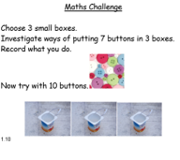
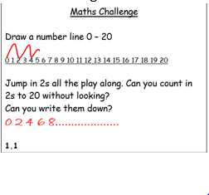
Mind fullness.
Colouring in mini beast some handouts on the blog.
Topic
We are still looking at the world and habitats on earth. Today though we are looking at insect’s habitats. Power point and hand out on the blog. I have also added a word search to do jointly together as an optional extra.

Diary dates (we will touch on these over the course of the next 2 weeks)
12th Feb Chinese New Year
14th Feb –Valentines
16th Feb- Chinese New Year
14th March Mother’s day.

