Monday 8th February 2021

I have received quite a few Gruffalo video’s and look forward to seeing the results. I would like to get the story sent out to the children by the end of the week. If you have not already sent yours, please would you sent it asap. Thank you.

Phonics
We only have completed the revision of set 2 sounds so today we are going to play a set 2 bingo game.

Set 2 sounds link: (please ignore the last 2 sounds)
https://www.youtube.com/watch?v=p7hRbrpq5Bo

Bingo board on the blog.

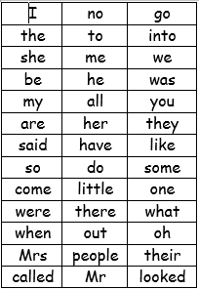
We have learned up to have and like on the red word list. This week we are learning so and do.
Please can you go through the red word list upto, do with the children? This could be timed , hidden, taken outside, matched , as a bingo game similar to set 2 etc.

SENTENCE, please write a sentence to go with the picture of the cat and mouse (on the blog).

Story.
https://www.youtube.com/watch?v=eVClAj8q_lY

Reading
Please read with your grown up once today.

Physical
https://youtu.be/T8jI4RnHHf0 Daily exercise 20 mins Animation and can be done in the classroom
However, if the weather great why not go outside, you could play hide and seek/ explore the woods/moors, play tag.
Maths today
https://whiterosemaths.com/homelearning/early-years/building-9-10-week-1/

Session 1 - Representing and Sorting 9 and 10
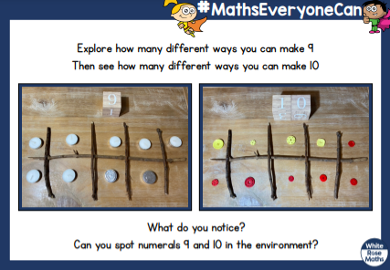
An extra activity can you identify 3d shapes? We will soon be looking at the properties of 3d shape in order to compare and describe a 3d shape.
https://www.google.com/search?q=you+tube+3d+shapes+eyfs&rlz=1C1GCEU_enGB821GB821&oq=you+tube+3d+shapes+
Mind fullness.
Start a happy jar, put in a note each day of anything that has made you happy.
Knowledge and Understanding of the World
This week will be learning about Chinese New Year and celebrating Valentines. We will come back to our topic to answer the question on the Earth or the Moon?
Locate China on a map. Discuss where in the world this is. Locate England (UK) on a map. Is China near us? Or is it far away?
Discuss Chinese New Year with the chn. Read the Chinese new year story to the chn.
What animals were in the story? How many altogether?
Discuss the different celebrations Chinese people carry out to celebrate Chinese New Year)
Exploring Materials
Chinese lantern instructions on the blog, for the children to make.

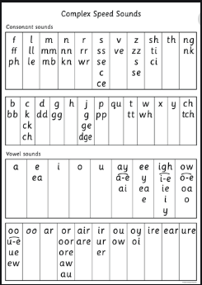

Diary dates
14th Feb –Valentines
16th Feb- Chinese New Year
14th March Mother’s day.

