Q1 Why doesn’t Cody want wings?

Q2 What’s the missing word?

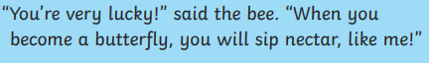

Q3 How many legs does the grasshopper have?
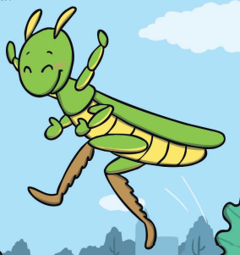

Q4 Sequence the pictures from the story using the numbers 1,2, 3, 4
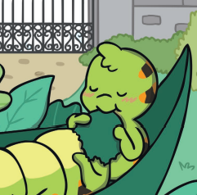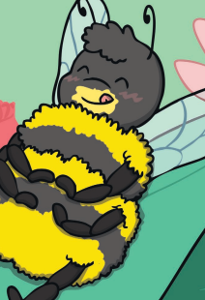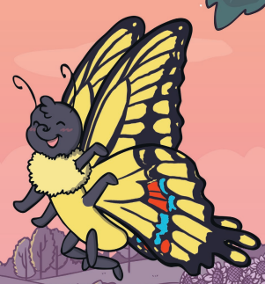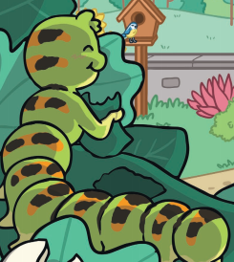

Q5
Write two sentences about the story you have read? (remember capital letters, full stops and finger spaces please)

