Tuesday 9th February 2021

Thank you for all the Gruffalo story lines.

Safer Internet day

https://www.saferinternet.org.uk/safer-internet-day/safer-internet-day-2021/i-am-educator/safer-internet-day-films/films-5-11-year

https://www.childnet.com/ufiles/Detective-Digiduck---150.pdf
Perhaps you could discuss what you have learned together afterwards.

We are still staying with set 2 sounds.
If you are confident you know your set 2 sounds can complete Making words and rhymes and Sort the words into the right boxes. You can use words that rhyme to make silly or funny sentences. I saw a bear sitting on a chair, brushing its hair. Use the words in the boxes to make up two more silly sentences. ( hand out on the blog)
Otherwise today we are going to play snap with the set 2 letter sounds. The idea is that you need to say the sound as you turn your card over. I have added set 2 to the blog.

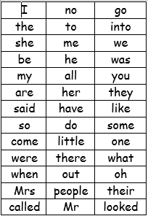
We have learned up to have and like on the red word list. This week we are learning so and do.
Please can you go through the red word list upto, do with the children? This could be timed , hidden, taken outside, matched , as a bingo game similar to set 2 etc.

SENTENCE, please write a sentence about Chinese New Year. Hand out on the blog.

Story.
https://youtu.be/Yowg1svWAyE

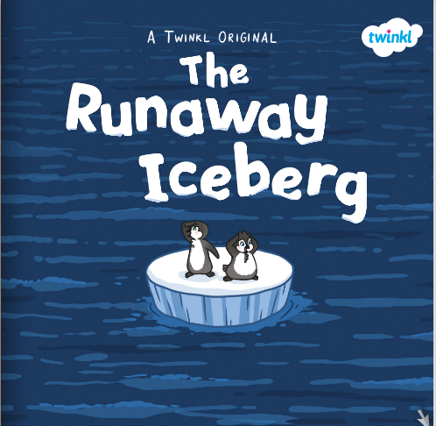

Reading
Please read with your grown up once today.

Physical
Cosmic kids Yoga https://www.google.com/search?rlz=1C1GCEU_enGB821GB821&sxsrf=ALeKk01avVuGMT04ybciWwp-kx6eFDegwQ:1612799483998&source=univ&tbm=isch&q=cosmic+kids+yoga&sa=X&ved=2ahUKEwjqt9mi0truAhXKTBUIHfvaBkgQ7Al6BAgKEBs&biw=1280&bih=423#imgrc=Wu2_iTxeWvaCzM
Or
Go outside and make a hopscotch you could even make this with your special friend sounds instead of numbers.
Maths today
3d shapes
https://whiterosemaths.com/homelearning/early-years/building-9-10-week-3/
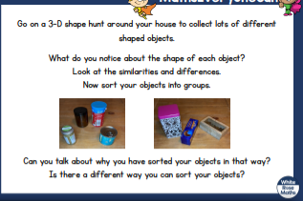
Mind fullness.
Pop a not in your happy jar and play your favourite music and have a little dance.
Chinese dance: if you want to feel inspired
https://www.youtube.com/watch?v=Bs0GuU0cUtw

Knowledge and Understanding of the World
Topic
https://www.youtube.com/watch?v=WQK4tAKNllo
can you name 2 Chinese national treasures?
How many days does Chinese New Year last for?
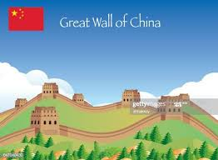
Exploring Materials
Instructions are on the blog.
