TASK ONE
Highlight the fronted adverbials in this extract from Alice in Wonderland. Can you say which type of fronted adverbial they are? Can you place a comma after the fronted adverbial? An example has been done for you.
Chapter 3 Nine Feet Tall
Alice didn’t cry for long. ‘Come on!” she told herself. ‘It’s no use crying. Stop this minute!’
Just then, (time adverbial) she caught sight of a small glass box lying under the table. Once more she was sure it hadn’t been there before. Slowly she opened the box and found one very small cake inside. On top of the box were two words, spelt out in currants: ‘Eat me’.
‘I shall eat it’ said Alice. ‘Perhaps it will make me bigger. Perhaps I can reach the key. Maybe if it makes me smaller then ever, I can probably creep under the little door and get into the garden anyway.’
Alice ate a small piece. ‘Which way am I going?’ she asked herself, a hand on her head to see if she was growing up or down.
Surprisingly she remained the same size. To be sure this is generally happened when one ate cake. But Alice had come to expect unexpected things to happen in the strange world where she found herself. She found it quite boring that nothing strange had happened. Happily she set about finishing the cake. As soon as she finished something did happen!
‘Curiouser and curiouser’ said Alice. ‘I think I’m being stretched out, and becoming taller and taller.’

TASK TWO
Now, write five fronted adverbial sentences of your own, where the fronted adverbials describe the time, place, frequency, possibility or manner of the action in your main clause. Can your sentences be about Alice in Wonderland? Use these pictures to help you.
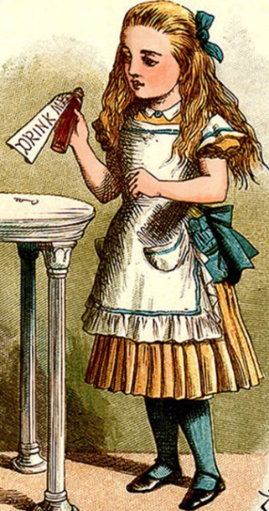
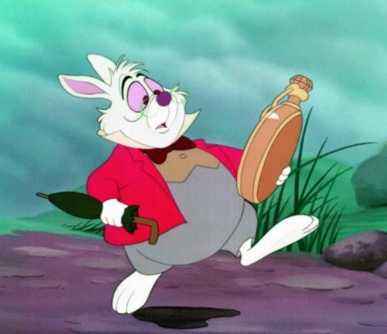
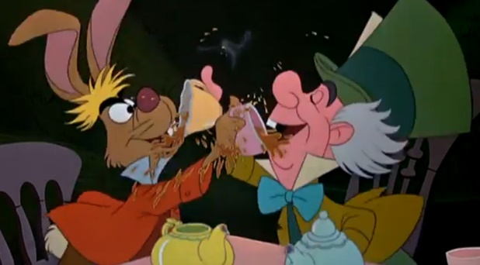

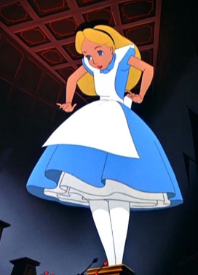

- (Time)

- (Place)

- (Frequency)

- (Possibility)

- (Manner)

