Spellings
Week beginning 23rd February
Year 5
forty
scorch
absorb
decorate
afford
enormous
category
tornado
according
opportunity
Year 4
science
crescent
discipline
fascinate
scent
scissors
ascent
descent
scientist
scenery

Please practice this weeks spellings. You may want to use one of these ways to practice your spellings:
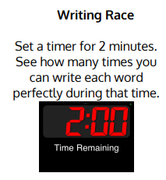
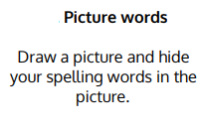

Can you write 5 of your spellings into a sentence?

