**The Zoo**

*The Zoo* uses concrete metaphors, comparing different animals in the zoo to different types of people or professions.

[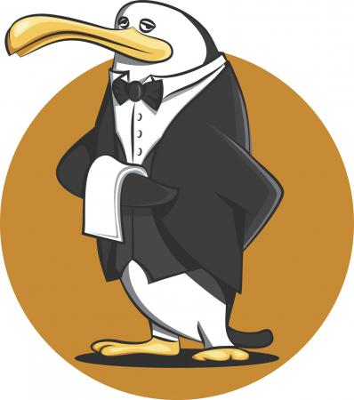](https://childrens-books.lovetoknow.com/image/209031~Butler-Penguin.jpg)

**The Zoo**

I thought it rather strange today,  
When visiting the zoo,  
To find the creatures living there,  
Are just like me and you.  
So wild and acrobatic,  
The monkeys in their cage,  
Delight in swinging high and low,  
Performers on a stage.  
Dignified and tall, the penguins on the ice,  
Waiters in their black and white,  
Proper and precise.  
Gazelles turn together,  
A troupe of graceful, dancing girls,  
Synchronized and slender,  
Performing plies, jumps, and twirls.  
Poor zebras are the prisoners,  
Condemned for life, you know,  
Their classic uniform of stripes,  
Truly marks them so.  
If I had all day, I'd surely make,  
Some other metaphors,  
For sloths, and tigers, elephants,  
And even dinosaurs.

**The Warrior**

This poem compares two unlike things: a tiny Chihuahua and a Scottish warrior chieftain.

**The Warrior**

Each night he walks his kingdom and nods to all he meets,  
His confident strut, his head held high; he roams through starlit streets.  
He growls a swift hello, his eyes all aglow,  
With warrior fire, and burning desire,  
To be proud Scottish Chieftain.  
Each night he dreams in 3-D, of dangerous battles galore,  
Shining swords, flashing daggers, moated castles, and more.  
His tartan wrapped tight; he enters the fight,  
He leaps at his foe, but then they laugh low,  
He is a Chihuahua you see.

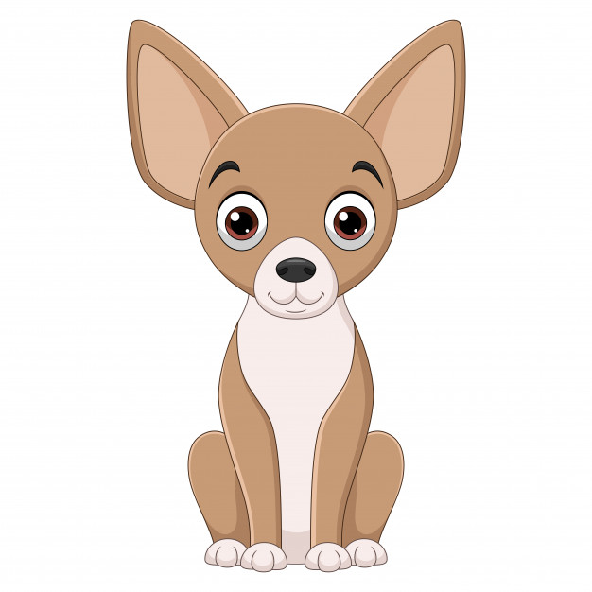

**A Strawberry Sundae**

*A Strawberry Sundae* takes the idea of an ice-cream sundae and describes it as a landscape. The ice-cream is a snowy mountain, the strawberry syrup a river, and the sundae is topped with multi-coloured sprinkles which resemble tiny, fairy-like flowers.

[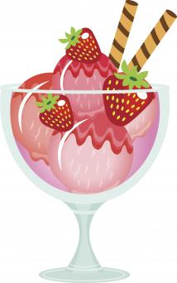](https://childrens-books.lovetoknow.com/image/209030~Ice-cream-and-strawberries-dessert.jpg)

**A Strawberry Sundae**

The shining peaks of white,  
The mountains soaring tall,  
Traversed with scarlet rivers,  
Multi-coloured waterfall.  
Upon the mountains high,  
Bright and vibrant shoots,  
Are scattered like the trace,  
Of tiny fairy fruits.  
But what is this I see?  
The mountains are receding,  
The sugar river flowing swift,  
Is quickly disappearing.  
And now there's nothing left,  
Of the mountains and the stream,  
Except a trace of pinkish snow,  
That smells like... ice cream.

READING COMPREHENSION LINKED TO METAPHOR QUESTIONS

You are all very good at remembering your VIPERSCO Reading Skills

V= Vocabulary

I= Inference

P= Predict

E= Explain

R= Retrieve

S= Summarise

C= Compare

O=Opinion

There will be a letter at the start of each question to indicate what skill you need to use.

**Questions on the poem “The Zoo”**

**1.V**

What do these words mean?

dignified:

synchronized:

plies:

troupe:

**2.S**

Summarise (in your own words) what this poem is about.

**3.O**

What is your opinion of the poem? Explain your answer.

**4. E**

Explain what you think inspired the poet to write this poem.

**5. R**

Which animals are “wild and acrobatic?”

**6. R**

Which animals are the “graceful, dancing girls?”

**7. I**

Why are penguins described as waiters?

**8. I**

Why are zebras “prisoners?”

**9. V**

Challenge Question: Write down three lines that are metaphors.

**10. O**

If you had to write the next few lines of this poem, what two zoo animals would you choose to include?

Extra Challenge: What metaphors would you use?

**Questions on the poem “The Warrior”**

**1.V**

What do these words mean?

strut:

aglow:

chieftain:

moated:

foe:

**2.S**

Summarise (in your own words) what this poem is about.

**3.O**

What is your opinion of the poem? Explain your answer.

**4. E**

Explain what you think inspired the poet to write this poem.

**5. R**

Who does the Chihuahua/Warrior nod to?

**6. R**

What weapons are mentioned in the poem?

**7. I**

Why do you think that his enemy laughs at him?

**8. I**

What phrase makes you think that his dreams seem very real?

**9. V**

Challenge Question: Write down one line or phrases that contains a metaphor.

**10. O**

If you wrote a poem about a dog, what breed of dog would you choose and what human would you compare them with?

(The metaphor here is that the Chihuahua is described as being like a brave Scottish warrior. I would choose a sheep dog and describe it as being a loyal friend.)

Extra Challenge: What metaphors would you use?

**Questions on the poem “A Strawberry Sundae”**

**1.V**

What do these words mean?

peaks:

traversed:

vibrant:

receding:

trace:

**2.S**

Summarise (in your own words) what this poem is about.

**3.O**

What is your opinion of the poem? Explain your answer.

**4. E**

Explain what you think inspired the poet to write this poem.

**5. R**

What colour are the rivers in the poem?

**6. R**

What is happening to the sugar river?

**7. I**

What do you think is meant by the line “shining peaks of white”?

**8. I**

Why are the mountain and the stream disappearing?

**9. E**

Why do you think the poet includes the sentence: “But what is this I see?”

**10. V**

Challenge Question: Write down one line or phrases that contains a metaphor.

**11. O**

If you wrote a poem about an item of food, what food would you choose and what kind of metaphor would you create?

(The metaphor here is that the Strawberry Sundae is described as being like a mountain full of snow that is melting. This is a strong metaphor because an ice cream sundae does look like a mini mountain and it melts in the same way that the snow on a mountain melts, so it is a clever metaphor.

I think I would choose a fried egg and describe it as the sun OR candy floss as a giant cloud that is attacking me!))

Extra Challenge: What metaphors would you use?