SPRING 2 2020– Year 4/5: PERFORMANCE POETRY
English Learning Journey: “Shape Poems”
Start the journey here…
Look at examples of a range of shape poems.
What makes a good shape poem? Likes? Dislikes?

Identify key features of a poem.
Identify structures.
Identify imagery.
Identify powerful vocabulary.

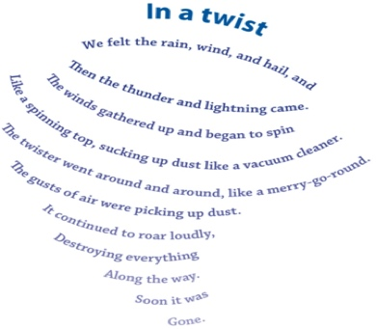
Evaluate and edit
Assess poem using toolkit.
Peer assess with another student/adult – 2 stars and a wish
Propose and make changes
Read aloud using correct intonation, tone and feeling.
Best copy
Write poem up in neat. Ensure that the shape is correct and use best handwriting for this.
Write a first draft.
As I write:
Proofread for spelling and punctuation
Check how it sounds.
Where our journey ends…
New skills – we will be learning how to:

- Add SHAPE to a poem
- Check the RHYTHM of the poem
- Create some powerful phrases.
- Set out / compose a poem.

We might reach for the sky and:
- Use METAPHORS in our writing
- Use playful RHYMES
- Learn new vocabulary for poetic terms

Create a toolkit that will help me to write a simple poem
Make our own toolkit and use this to self-assess our work.

Plan the poem.
Decide on a theme for poem.
Decide on a simple shape for the poem.
Gather interesting vocabulary to include.

Learn how to gather ideas for a poem.
Brainstorm powerful vocabulary, metaphors.
Look at different shapes.

