French – Lesson 1
Follow the link to watch the lesson and complete the activities:
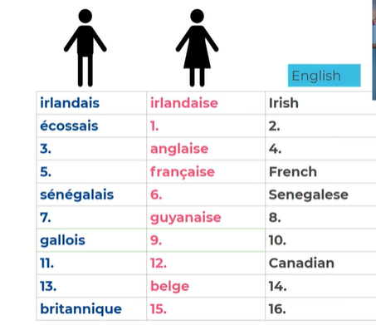
https://classroom.thenational.academy/lessons/saying-your-nationality-crup6d
Questions:
1. ‘I am’ in French is .
Translate these sentences in to French:
2. I am French.
3. I am Canadian.
4. I am British.

