Useful websites
Reading eggs
https://readingeggs.co.uk/

Oxford Owl
https://www.oxfordowl.co.uk/

Wednesday 24th February 2021
Keep going we are getting closer to the end!!!

Phonics
Please look at the set 2 sounds again, why not make this as playful as possible.
Today we are going to be looking at vowel sounds. Sorry this is not my lesson, but I will ensure there is one tomorrow.
https://www.youtube.com/watch?v=fR5r1EXLyuM
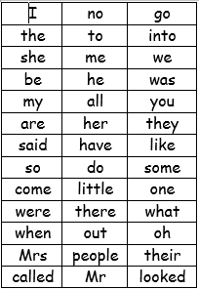

We have learned up to so and do on the red word list. This week we are learning some and come.
Please can you go through the red word list upto, do with the children? This could be timed , hidden, taken outside, matched , as a bingo game similar to set 2 etc.

Story.
https://youtu.be/88MnpGFFL4g

Room on the Broom. 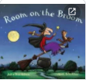
Who is the main character
What was the first thing the wind blew of the witch
Who found the witches hat
Who found the witches bow?
What did the dragon want to do?
How did the witch get a new broom?
What is your favourite part of the story?

I have added a couldron hand out on the blog for you to write your own potion. There is also a science potion attached on the blog just incase you want to make your own witches potion.
Maths
This week we are looking at sharing equally between groups.
https://vimeo.com/471009909

Reading
Please read with your grown up once today.

Physical
Joe Wicks the Froggy Coach
https://www.youtube.com/watch?v=16FIVgWUklY
or
Go outside and ride your bike/scooter.

Try to put your own coat on independently today, can you zip your coat up all by yourself?

Well Being
Some colouring added to the blog.

