Useful websites
Reading eggs
https://readingeggs.co.uk/

Oxford Owl
https://www.oxfordowl.co.uk/

Thursday 25th February 2021
Keep going we are getting closer to the end!!!

Phonics
Please look at the set 2 sounds again, why not make this as playful as possible.
Today we are going to hold and write a sentence using our set 2 sounds.
https://youtu.be/lGF4ntq22FI

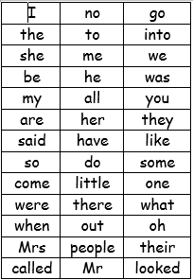

We have learned up to so and do on the red word list. This week we are learning some and come.
Please can you go through the red word list upto, do with the children? This could be timed , hidden, taken outside, matched , as a bingo game similar to set 2 etc.

Story.

https://youtu.be/2DUkdXEJZhA

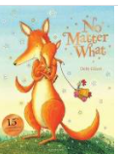
Did you spot any rhyming words?
Please see the blog for some additional rhyming words.
Maths
This week we are looking at sharing equally between groups.

Provide 2 teddy bears, 2 plates and small even quantities of loose parts to represent different food items. Ask the children to share out loose parts equally so that the teddy gets the same. What will happen if another teddy joins the picnic?

Please point out how many items are being shared and how many groups.
We normally share by saying one for you and one for you , making sure each group receives an item.

Hand out on the blog if required.

Reading
Please read with your grown up once today.

Physical/ C-beebies
https://www.bbc.co.uk/cbeebies/grownups/fun-exercises-to-do-at-home-with-kids
or
Go outside and go for a walk with your grown up

Try to put your own coat on independently today, can you zip your coat up all by yourself?
Can you make your own bed?

Well Being
Cook some biscuits and share them between your family.
Mary Berry’s fork biscuits
https://thehappyfoodie.co.uk/recipes/fork-biscuits
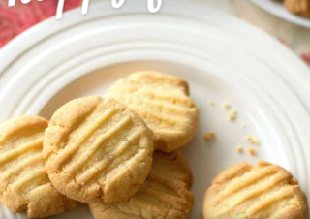

Topic
Today I want you to discuss, what you have learned about the moon and what you have learned about the earth.
Here is a very short clip that links gravity from the moon to the tides.
https://www.facebook.com/bbcbitesize/videos/269231797108701/

