Useful websites
Reading eggs
https://readingeggs.co.uk/

Oxford Owl
https://www.oxfordowl.co.uk/
Friday 26th February 2021
I can finally say it, only 1 week to go now and we are incredibly excited. It has not been the same at school, without all of the children. We are so looking forward to seeing them again!
Phonics
Today we are going to look at the formation of the letters
https://www.youtube.com/watch?v=ijd45Qddxfo
please can you practise writing them? Especially the ones you struggle with.

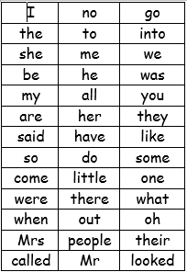

We have learned up to so and do on the red word list. This week we are learning some and come.
Please can you go through the red word list upto, do with the children? This could be timed , hidden, taken outside, matched , as a bingo game similar to set 2 etc.

Story.
https://youtu.be/U29jadFQF9Y

There are a few rhyming words in this story, can you spot them? I have added a rhyming power point to the blog page.
Can you remember the actions in the story? – you could even write them to help you.
Can you retell this story in your own words?
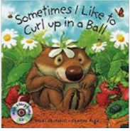

Maths
Sharing
https://www.youtube.com/watch?v=ivXfT-sei8M
counting
https://whiterosemaths.com/homelearning/early-years/building-9-10-week-2/

Reading
Please read with your grown up once today.

Physical
Play the bean game- you could be a jumping bean, running bean, string bean, French bean, jelly bean, baked bean, broad bean, baked bean etc..
Or
Go outside and see if you can do this challenge.
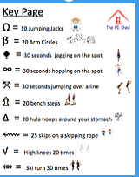

Well Being
Why not play a board game together or you could show your adult how to play chase the cat and you think of the word and the adult has to guess the letter sounds.
Or
Get some playdough out and enjoy rolling it and making models.
Topic
We have finished our topic and need to answer the question the Earth or the Moon?
Can you decide if you prefer the earth or the moon and say why? You could even draw a picture showing us which you prefer.
We would be really interested in hear your views. In class we will make a pictogram to find the overall answer.

