Reception Newsletter

Tuesday 23rd February 2021

We are pleased to inform you that Mrs Chapman is returning to school this week after finishing her maternity leave. She will be joining the Reception class on Thursday and Friday and we anticipate that this will give us additional time to help the children make the most of what is left of the Reception Year.

We are thrilled to have been fortunate enough to have gained funding and the training for the NELI (Nuffield Early Language Intervention). We plan to start this as soon as the children are all back at school.

If you think you are eligible for Pupil Premium please can we ask you to go on line and complete the form.

<https://www.cornwall.gov.uk/education-and-learning/schools-and-colleges/school-meals/>

Thank you for your continued support through these difficult times. We are here and fully appreciate that this year has impacted on parent visits to school. I aim to re-arrange a time for parent discussions but in the meantime we are here if you do want to talk.

Learning

This week, we will be revisiting RWI set 2 sounds to check that we are ready to move on to set 3 sounds. Please do not worry if your child is still working on set 2 sounds, lessons will be provided for set 2 and set 3.

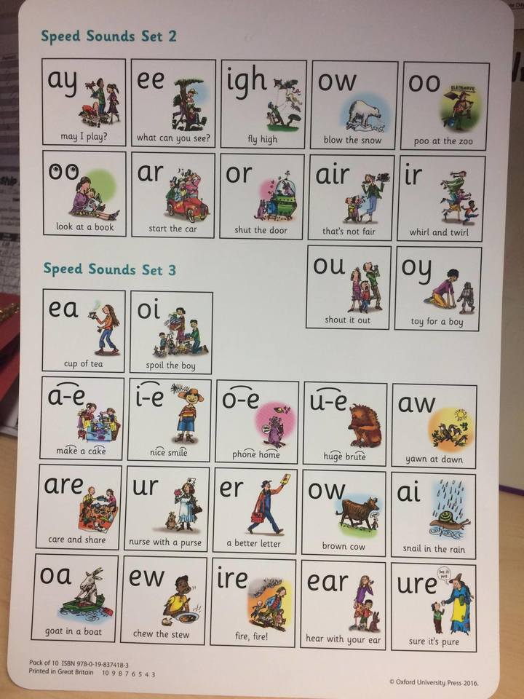

In maths this week, we will be learning to share amounts equally between groups. The language involved will be: share, divide, equal, the same.

We will be completing our topic in readiness for Alice in Wonderland and asking ourselves the question of which we prefer, ‘The earth or the Moon ‘?

Diary dates

World Book Day -4th March, we would love to see Home Learners and children attending school dress up for this occasion.

Alice in Wonderland- whole school Dressing up -8th March

Red Nose Day- 19th March

School closes Friday 2nd April 2021

Parents meetings TBC

A big well done to everyone and a big thank you for all your support. Let’s hope we get some normality back soon.

Optional home work

It is always beneficial to read with your child 3 times per week. Please can you ensure that you record reading in your child’s reading record book so that we can monitor how often they are reading.

You could ask the children to share the plates, pencils, pieces of fruit etc equally at home this week.