English Diaries – Lesson 1

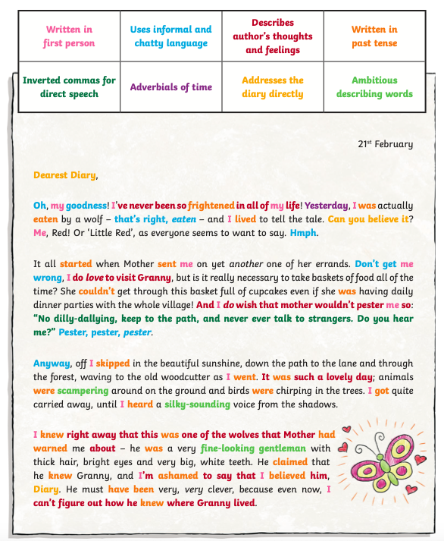
Choose a diary extract. Read it through then make a key of grammatical and structural features. Use a highlighter or colouring pencil to highlight these features in the text. There is an example below and on the PowerPoint.

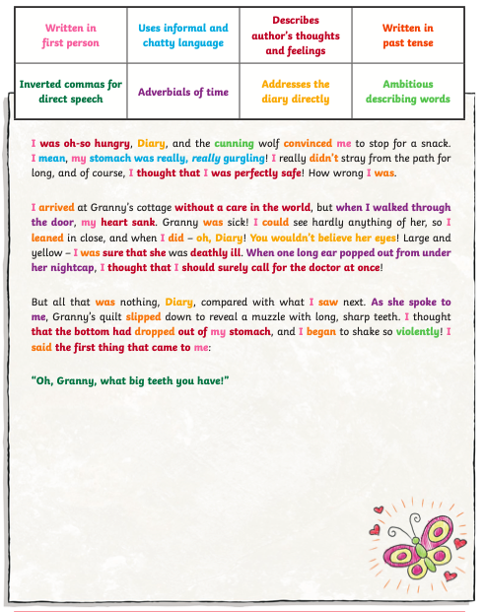

Monday 18th May 1879
Dear Diary,

You’ll never believe the day I’ve had!

It started off like an ordinary day. I was playing outside with Sarah (that’s my big sister) and she was REALLY annoying. She took out her book, so I wondered off to the bottom of the garden and sat underneath the big cherry blossom tree where it was nice and shaded. Out of the corner of my eye, I noticed something strange: an anxious, white rabbit, dressed in a waistcoat and holding a shiny, golden pocket watch. I couldn’t help moving closer towards it. It seemed to be muttering to itself, “I’m late! I’m late! For a very important date.”

I was curious to know where it was going so, looking back to check my sister wasn’t watching me, I rushed over to follow the rabbit. It was going so quickly and seemed to be going through a hole…

Then, suddenly, WHOOOOOSH! I was tumbling through the air! Wind swirled around me like a tornado and I screamed and screamed as hard as I could. Down, down, down. The walls were covered with cupboards, bookshelves and clocks. Eventually, I landed with a thump on the ground and found myself in what looked like a small room. I still haven’t worked out where I am – it’s definitely NOT my garden and I don’t know how I’ll get home. Oh diary, I hope I’m not stuck here forever!

Tuesday 19th May 1879
Dear Diary,

I’ve FINALLY figured out where I am! Well, sort of…
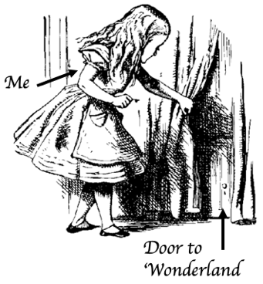
I was recovering from my fall in the strange room (I hit the ground extremely hard when I fell), when I noticed something gleaming in the corner. There was a crooked, wooden table with a tiny, glass bottle on top of it. I edged closer – it seemed to say ‘drink me’ on it. There was also a minute golden key. How curious!

Now, I know what you’re thinking diary, one mustn’t drink things when they don’t know what they are, but I was desperate and terribly thirsty. I took one tiny sip and then WHOOOOSH AGAIN, I was suddenly shrinking! I was as small as a mouse. I looked around the immense room for something to help me. I found a door but it was locked – it turns out that I needed that key on the table. How was I going to grow big again? After some searching, I found a delicious piece of cake with ‘eat me’ on. I bravely took a bite and, to my relief, I started growing. And growing. And growing…

Then, OOOMPH! My head hit the ceiling with a nasty THUMP and I was still growing! I looked around hastily for the table. I saw the key gleaming in the corner again and grabbed it. I then took it over to the little door. CLICK! The door was open. I peered through the door with one eye (that’s all that would fit) and saw a stunning forest with a little sign that seemed to say ‘Wonderland’. Oh diary, it looked so inviting but I was just too tall to fit through.

I’m going to have to go now, I can feel some tears coming. How could I be so stupid? I’m never getting out!

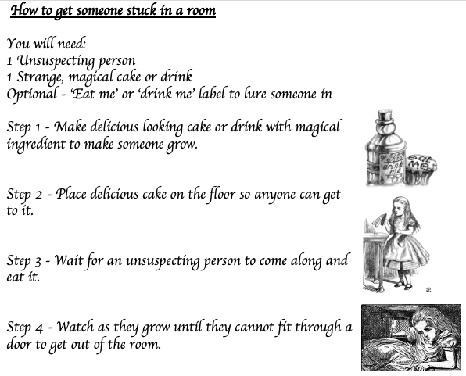
Wednesday 20th May 1879
Dear diary,

What a day!!!!

After my epiphany yesterday (the realisation that I was no longer in my back garden but instead somewhere in ‘Wonderland’), I decided to seize the day and explore. I’d ended up crying a lot so there was a little pool of water at the bottom and my feet were very wet. Nevertheless, I pulled myself together, put the key in my pocket and took a sip from the magic drink. WHOOOOOSH! I shrank down so that I was as small as a mouse.

Everything changed. What to me had felt like a little annoyance, had become much worse. The little pool was now a sea! I swam as fast as I could to the door and then I was THROUGH!!!

My tears had caused gigantic waves in Wonderland and I swam amongst strange creatures, who were angry with me for crying, but it wasn’t my fault. How was I supposed to know that my tears would cause a flood?

Oh diary, they were SO cross with me. My heart was racing, the hairs on my arm were beginning to stand on end, and I began to panic. The water. The noise. The animals. It was all too much for me.

I HAD to get back home… but how?

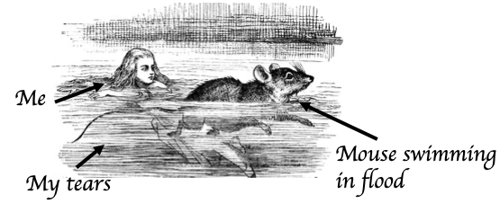

Extract from: Diary of Dennis the Menace

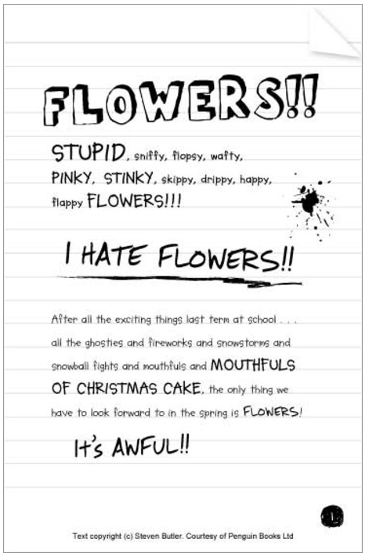

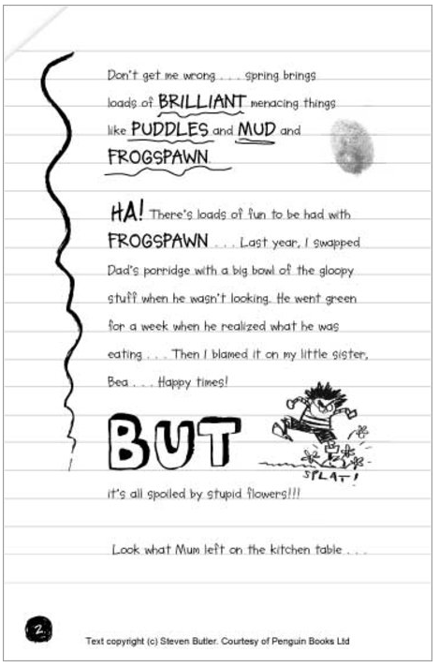
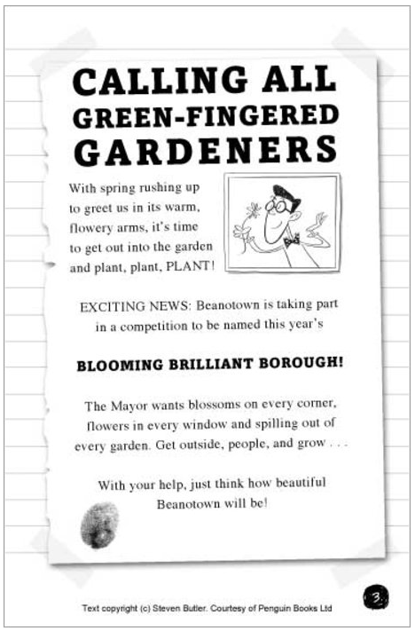

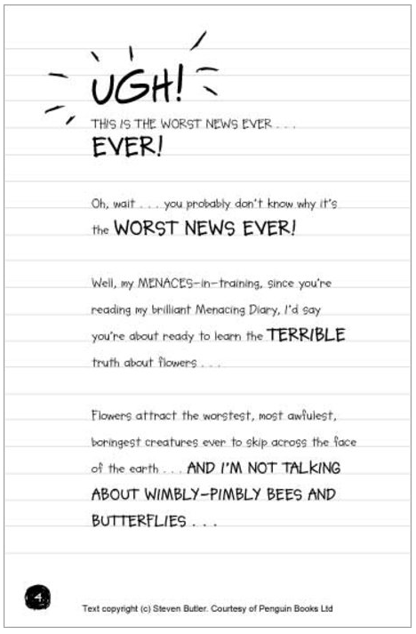

Christopher Columbus Diary:

