YEAR 4/5 TASKS FOR WEEK BEGINNING 1/3/21

ART
Find pictures of the characters (or use these) from Alice in Wonderland and have a go at drawing one of them in as much detail as you can.
It would be nice to display some of them when you are back at school.
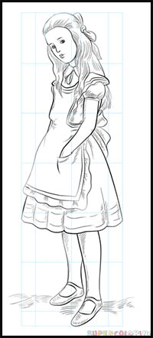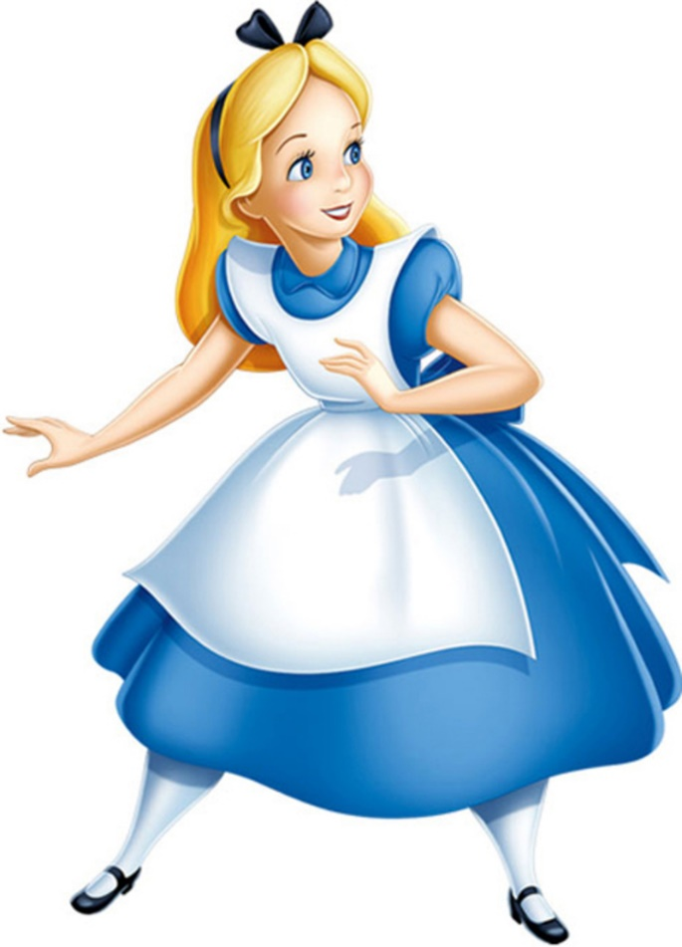

Can you work out or find out who all these characters are?

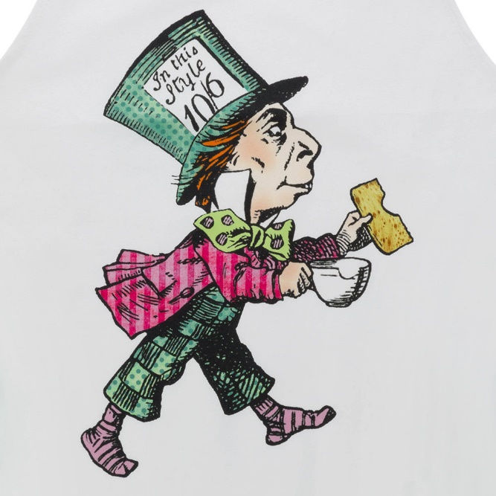
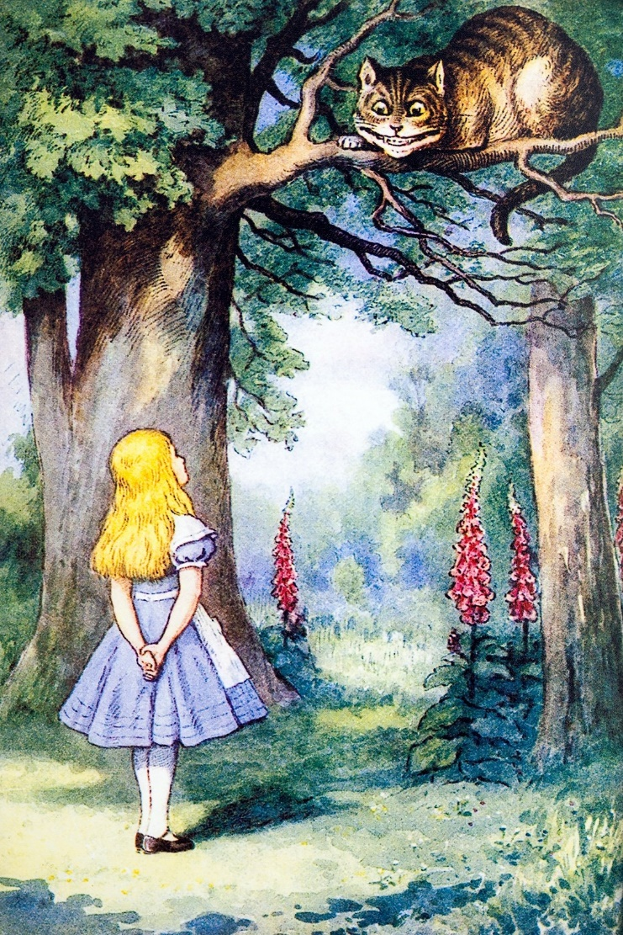
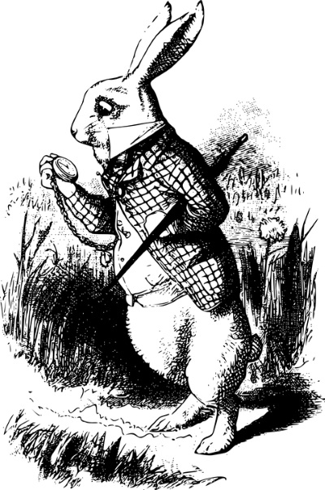
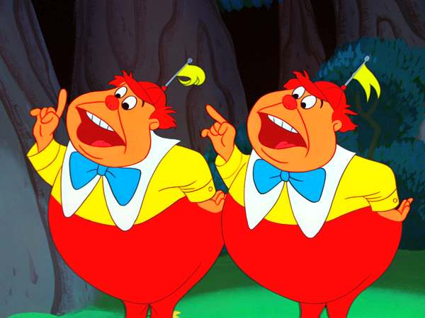

FOREST SCHOOL
AIM: To make a “natural” cup and saucer for an animal at the tea party in “Alice in Wonderland.”

Use a plastic/paper cup and plate as the base and then gather lots of natural objects to stick on to it.
You may want to cover it in foil or paper to make the bits and pieces stick better. If you need some PVA glue, please let Miss Parris know.

You can adapt this task. Perhaps you can think of a better way to do it.
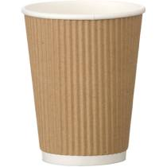
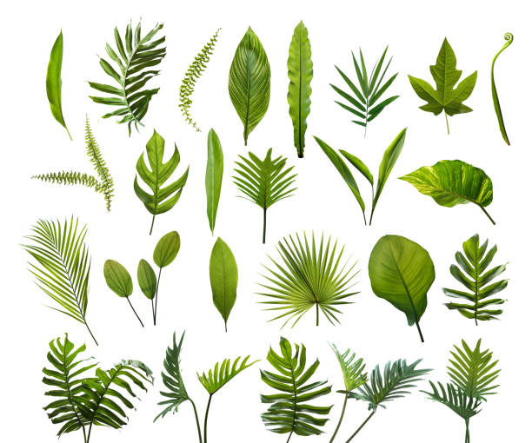

You could use leaves, grass, bark, flowers, petals, moss etc.

MUSIC
Create an un-tuned musical instrument out of scrap materials from home.
It could be as simple as an elastic band stretched across a tissue box or a saucepan and a wooden spoon drum kit.
You could challenge yourself to make some panpipes out of straws.

See what ideas you can come up with.

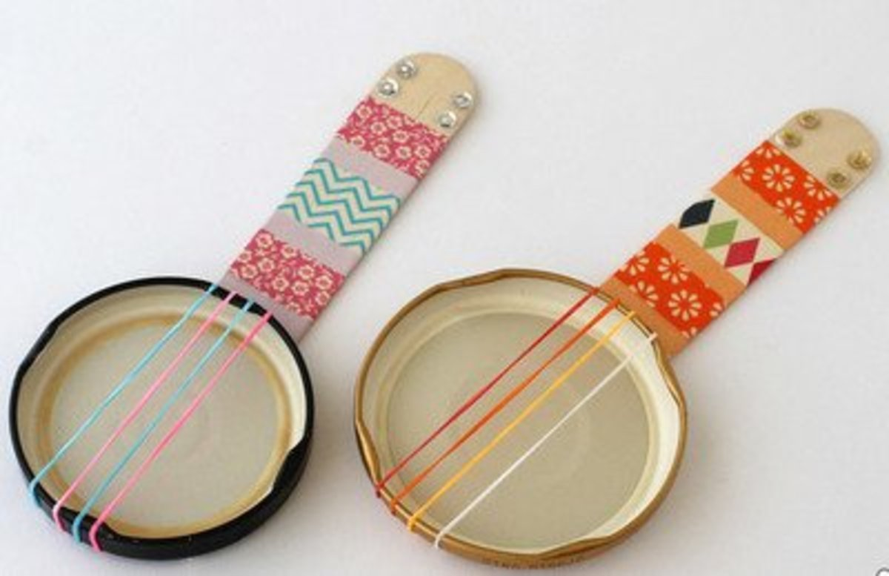

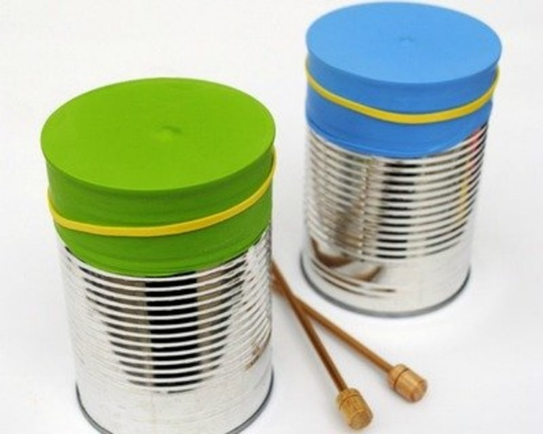

PRESENTATIONS
Keep working on your presentations. This is an optional task.
For those children who are doing it, please bring your presentation to school for the last week of term.
If you need any resources for this, please contact Miss Parris and I will do my best to get them to you.

READING
Please keep reading. If you can get hold of a copy of Alice in Wonderland (there are many good shorter versions and picture books), it would be really good to familiarise yourself with that story.

SCIENCE
There will be a live lesson with Mrs Nute on Tuesday.
Your topic is “Forces.” Please take some time to look at some of the fantastic resources and videos on BBC Bitesize.

