Useful websites
Reading eggs
https://readingeggs.co.uk/

Oxford Owl
https://www.oxfordowl.co.uk/
Monday 1st March 2021. Book Fortnight- Alice in Wonderland.
World Book day is 4th March and we would love to see you dressed as your favourite character.

Phonics
Please see the air power point on the blog page.
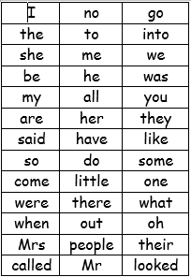

We have learned up to some and come on the red word list. This week we are learning sone and were.
Please can you go through the red word list upto, do with the children? This could be timed , hidden, taken outside, matched , as a bingo game similar to set 2 etc.

Story.
This week we start Alice in Wonderland
https://www.youtube.com/watch?v=Y-0JC28xxTY

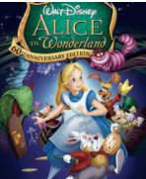

Please see Mrs Spencer’s challenge.
https://www.youtube.com/watch?v=QWCEBgmtnXU&feature=youtu.be
Can you design a recipe fit for a queen? What will make the recipe special and is it fit for a queen?
Template on the blog page.

Maths
Looking at the number 11 and teen numbers today
Please see the handouts on the blog page.

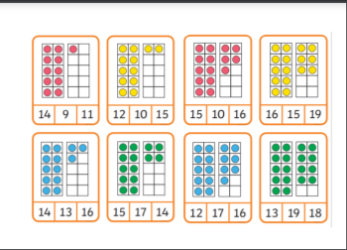
Reading
Please read with your grown up once today.

Physical
Some challenges today.
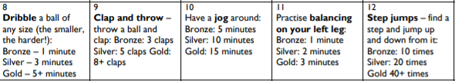

Mindfullness
Alice in Wonderland spot the difference.
Topic
Alice in Wonderland- talking Flowers
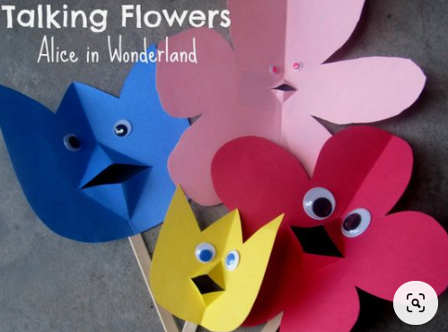
Diary dates this week
4th March –World Book Day
5th March- St Piran’s day

