Useful websites
Reading eggs
https://readingeggs.co.uk/

Oxford Owl
https://www.oxfordowl.co.uk/
Tuesday 2nd March 2021. Book Fortnight- Alice in Wonderland.
World Book day is 4th March and we would love to see you dressed as your favourite character.

Phonics
The oo (poo at the zoo ) and oo (look at a book can be confusing, so today we are going to look at oo poo at the zoo.
https://youtu.be/1OO8vt7cnGw

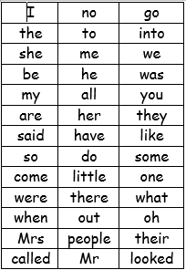

We have learned up to some and come on the red word list. This week we are learning sone and were.
Please can you go through the red word list upto, do with the children? This could be timed , hidden, taken outside, matched , as a bingo game similar to set 2 etc.

Story.
Today’s story is another Alice in Wonderland story.
https://youtu.be/jWk1Izs9AWQ

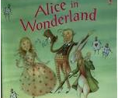

Who is the main character in the story?
What did Alice nibble?
What did Alice drink?
What did the White Rabbit drop?
How did the story end?

Reading
Please read with your grown up once today.

Maths
Ordering numbers to 20
https://classroom.thenational.academy/lessons/ordering-numbers-up-to-20-6rt3ad

Physical
Some challenges today.
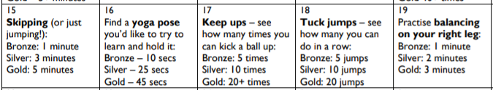

Well being
Please see the blog page for a mini beast hunt.

Topic
Alice in Wonderland
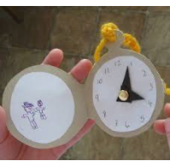
Colouring activities are also on the blog.
Diary dates this week
4th March –World Book Day
5th March- St Piran’s day

