Useful websites
Reading eggs
https://readingeggs.co.uk/

Oxford Owl
https://www.oxfordowl.co.uk/

Wednesday 3rd March 2021
World Book day is 4th March and we would love to see you dressed as your favourite character on Thursday.

Phonics
Yesterday we looked at oo (look at a book) and today we are going to look at oo poo at the zoo.
https://youtu.be/2bLxQwTfuiw

This week we are learning the tricky words some and were.
Please can you go through the red word list upto, do with the children? This could be timed , hidden, taken outside, matched , as a bingo game similar to set 2 etc.

Story.
The gingerbread man.
https://www.youtube.com/watch?v=U89dkGrsYZY
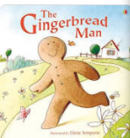
There are some thought bubbles on the blog page.
Reading
Please read with your grown up once today. Can you find your favourite book and decide on which character you want to be for World Book Day.

Maths
https://whiterosemaths.com/homelearning/early-years/building-9-10-week-1/
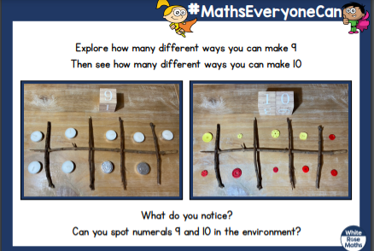

Physical
Some challenges today.
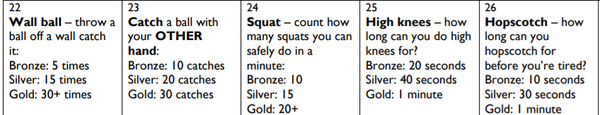

Alice in Wonderland Yoga
https://www.bing.com/videos/search?q=good+way+to+introduce+alice+in+wonderland&docid=607993196014865596&mid=5CF448A19047891C9D435CF448A19047891C9D43&view=detail&FORM=VIRE

Topic/well being
Alice ruined the Mad hatters Tea-party. (Please see the note below).
Alice said she was very thirsty and asked for a cup of tea. I do love a cup of hot, tasty tea!
I thought Alice was very rude as she called us all mad! Mad! After that I decided it was time for my tea party to end and sent Alice on her way!
The mad hatter
Oh dear Alice was a little rude and the Mad Hatter is not happy. Perhaps today you could make another tea party at home with your toys, to send and show the Mad Hatter.
Can you write a menu and the name cards? How many plates, forks, knives are you going to need?
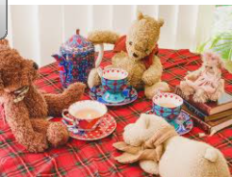

Diary dates this week
4th March –World Book Day
5th March- St Piran’s day

