Useful websites
Reading eggs
https://readingeggs.co.uk/

Oxford Owl
https://www.oxfordowl.co.uk/

You can also access phonics play - PhonicsPlay
Free log on details:
Username: jan21
Password: home
There are some great games on here to test your phonic knowledge.

Thursday 4th March 2021
It is World Book Day today.
Phonics
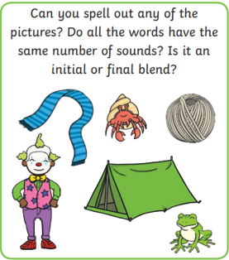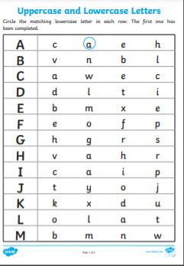
The link for you to access the phonic lessons is: Ruth Miskin Training - YouTube
set 2 sounds.
This week we are learning the tricky words some and were.
Please can you go through the red word list upto, do with the children? This could be timed , hidden, taken outside, matched , as a bingo game similar to set 2 etc.

Story.
I have put a story on the blog page for you today. Can you guess what might happen in this story ?
https://youtu.be/r2eUPhn4uUI

Since it is World Book Day, why don’t you go and read a book in a reading den. This could even be under the table. Please send us a photograph of your self-dressed up and we will try to guess who you are.

Just for fun, I have put a name that story power point on the blog. How many stories do you recognise?

Poetry (I hope the link works)!!!!
https://www.youtube.com/watch?v=FZDTblrzw-o&t=3s

Maths
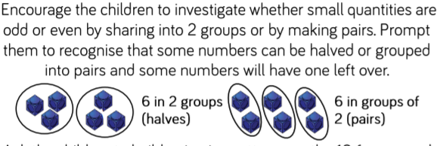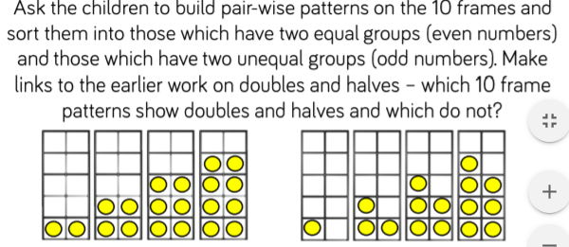

Physical
Some challenges today.

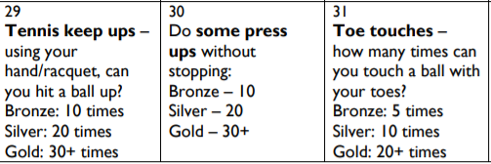

Topic/well being
Design a tea pot, please see the blog page.
Diary date
5th March- St Piran’s day

