English Diaries – Lesson 5

On Monday 8th March, everyone is returning to school (Yay!). On Monday, we are having an Alice in Wonderland day where everyone can dress up as characters from the story. Year 4 and 5 are also having a ‘Mad Hatter Tea Party’ on this day. In preparation for this, we would like you to look at some quotes from Alice in Wonderland and make a piece of artwork out of them. You will need to learn this quote by heart. Below are some quotes and ideas.

Quotes:
- "Off with their heads!" ...
- "Why, sometimes I've believed as many as six impossible things before breakfast." ...
- "It's no use going back to yesterday, because I was a different person then." ...
- "We're all mad here." ...
- "Curiouser and curiouser!"
- "It takes all the running you can do, to keep in the same place. If you want to get somewhere else, you must run at least twice as fast as that!"
- "'Who in the world am I?' Ah, that's the great puzzle!"
- "It would have made a dreadfully ugly child; but it makes rather a handsome pig."
- "'And what is the use of a book,' thought Alice, 'without pictures or conversation?'"
- “How long is forever? Sometimes just one second.”
- “You’re entirely bonkers but I’ll tell you a secret. All the best people are.”

Make a poster out of a quote from Alice in Wonderland. This should be no bigger than A4 size as this could go on display in the classroom.

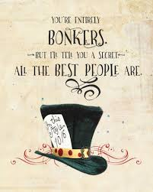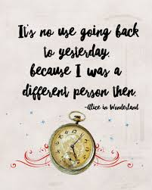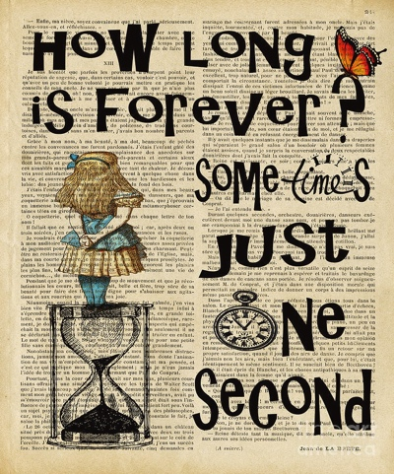

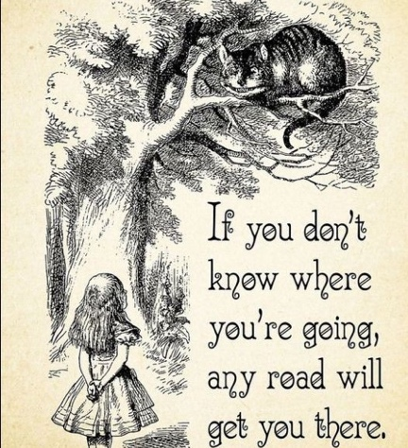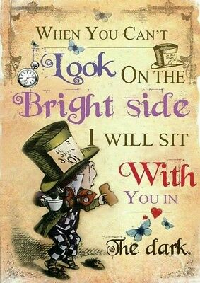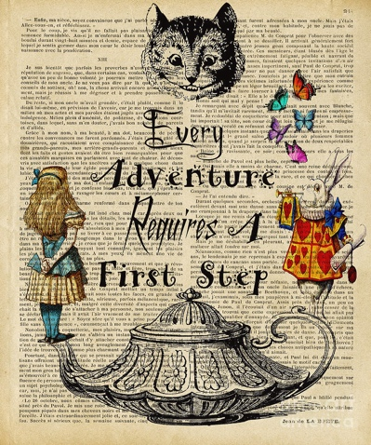

Make some bunting with quotes on.

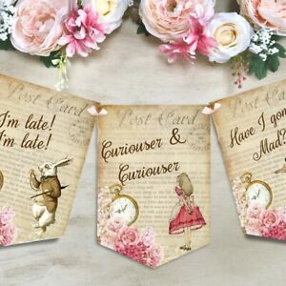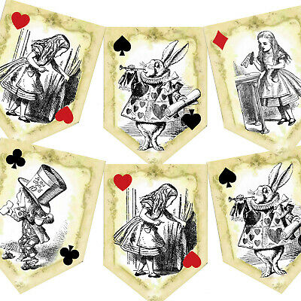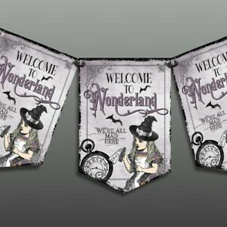

Make some cake toppers.

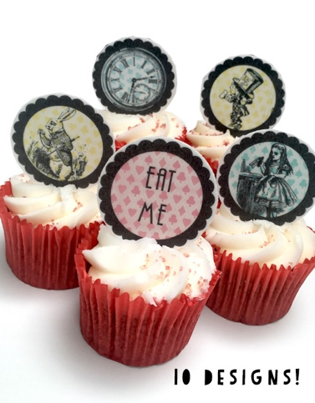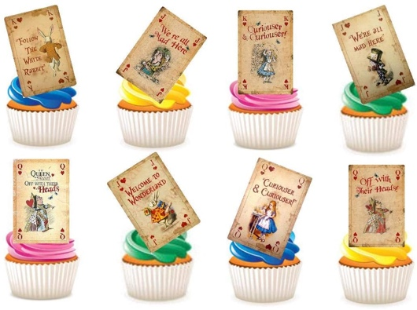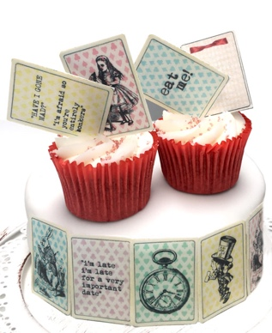

Make decorative table runners.

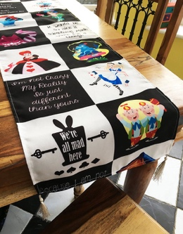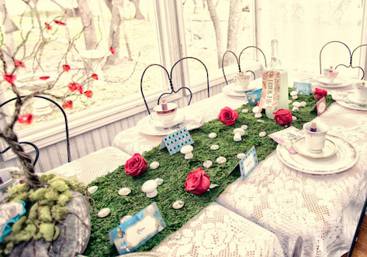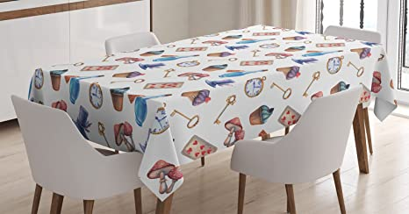

(Optional Extras) Make decorations/costumes for the day.

