Useful websites
Reading eggs
https://readingeggs.co.uk/

Oxford Owl
https://www.oxfordowl.co.uk/

You can also access phonics play - PhonicsPlay
Free log on details:
Username: jan21
Password: home
There are some great games on here to test your phonic knowledge.
Friday 5th March 2021
It is St Piran’s day, today and our very last day of Home Learning.
In school today at 9.10 we are all stopping to sing Trelawny, why not join in with us. I will put the words on the blog.

Phonics
Please use today as a chance to go over any letter sounds and letter formation that you might find tricky.
Set 1
https://www.youtube.com/watch?v=TkXcabDUg7Q&t=17s
set 2
https://www.youtube.com/watch?v=p7hRbrpq5Bo

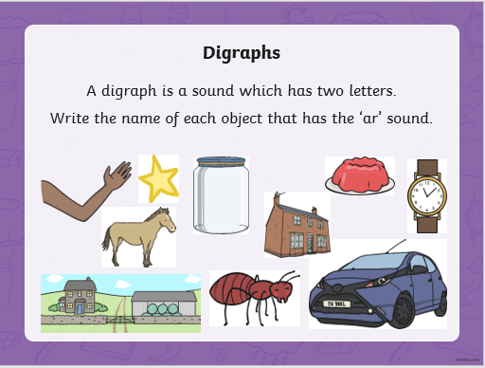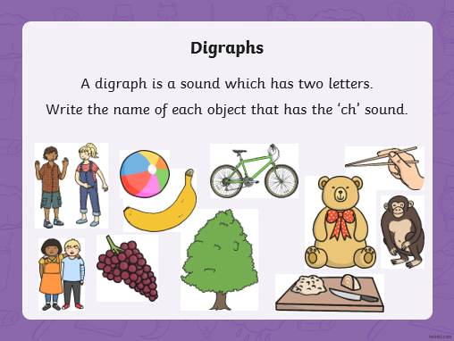

Story.
Your choice today. When the children click on the image of the book, it takes them through to a video of the author reading from their book.
Please see the Blog (wbd-digital-library (4))

Maths- lots of challenges today
Doubling and halving.
https://classroom.thenational.academy/lessons/double-and-half-of-numbers-within-20-65jp8d?activity=video&step=1

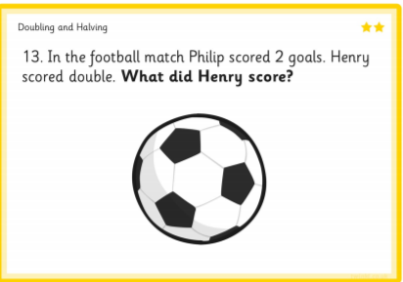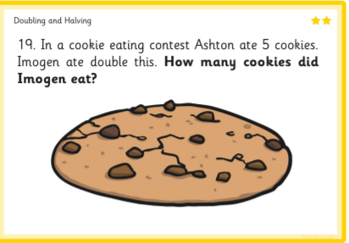

Physical
Some challenges today.
Go outside for 30 minutes. Make a hop scotch, throw and catch a ball, take a skipping rope or dribble a ball around some obstacles.

St Piran’s day
I have added a power point to the blog page and a flag template to make a Cornish Flag with.

