January 2021

Hi all, thank you to those of you who posted on Tapestry over the last couple of days. Look at the blog and see if you can spot your photo! I have attached some more home learning ideas on Tapestry. Here is a guide on how you could structure a morning or afternoon with your child which is like what we would do during a typical session.
First thing: We say good morning, sing our days of the week song (https://www.youtube.com/watch?v=oKqAblcwFOA) then we talk about what the weather is like and then sing a nursery rhyme. These can be found on the bbc nursery rhymes website: https://www.bbc.co.uk/teach/school-radio/nursery-rhymes-five-little-men-in-a-flying-saucer/z6qgscw (5 little men in a flying saucer)
Scroll down to find a link to space yoga!
(Space yoga) Yoga Time! | Space Picnic - Kids Yoga and Nursery Rhymes - YouTube

Home learning ideas: (These are also on tapestry)
Make your own name rocket this tine using the sounds from your name. Can you remember the names of the sounds?

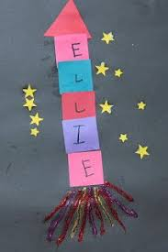

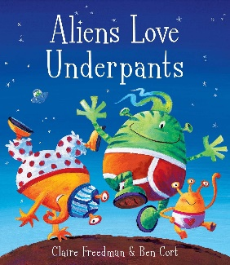
Story: Aliens love underpants
Bedtime Stories | Maggie Aderin-Pocock | Alien's Love Underpants | CBeebies - YouTube
Do you have any books about space or space stories at home?
Can you tell me what you know about space?
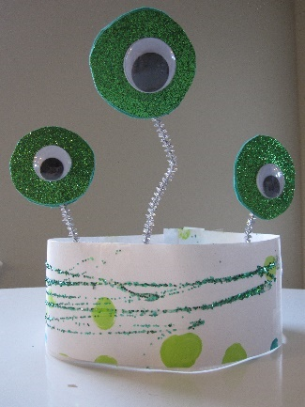

Can you have a go at making an alien headband. You will need: paper, pipe cleaners, googly eyes or eye stickers, card, glitter and other decorations.

Sensory play: You could make a sensory space bottle.
Equipment needed: Plastic bottle, water, food colouring, glitter, any space themed objects to put inside. (star sticker, a rocket, rocks or pebbles)
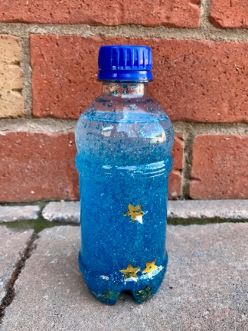

Types of play: Imaginary: This is important for children as it helps to develop their language, social skills, and ability to use their imagination. This could be done through acting out stories, role play such as kitchen/home, baby dolls or animals.
Fine motor skills: We do lots of fine motor practice in pre-school. It is particularly important to strengthen the children’s muscles in their hands. This can be done in many ways:
Play dough – rolling and squeezing
Scissor skills practice
Threading beads or something similar
Puzzles
Lego/block play

