February 2021

Hi all, thank you to those of you who posted on Tapestry over the last couple of days. Look at the blog and see if you can spot your photo! I have attached some more home learning ideas on Tapestry.
Our focus for the next couple of weeks is Insects.
Incy wincy spider - BBC Teach (Sing the Incy Wincy Spider song)

(Insect Yoga) Kids Yoga all about BUGS! 🐜🐞🕷🐝🐛 - YouTube

Home learning ideas: (These are also on tapestry)
Make your own insect using materials you have at home
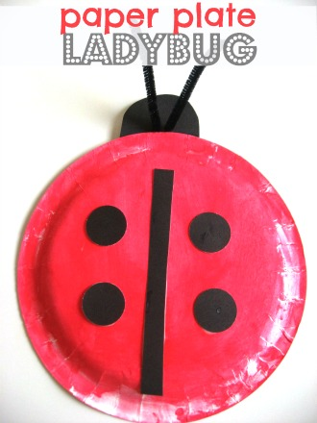
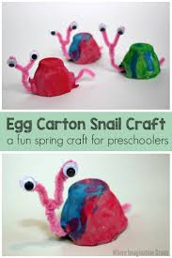
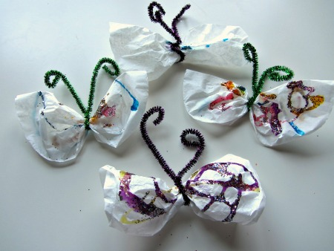

Story: The Very Hungry Spider
The Very Hungry Spider (Sillywood Tales) - An animated children's story book - YouTube
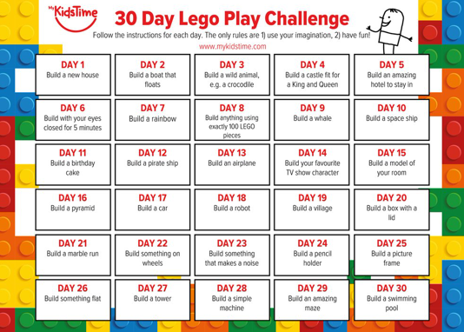

Can you try the daily Lego Play Challenge?

Sensory play: Make some chocolate play dough (flour, salt, warm water and cocoa powder)
Have fun making and decorating some heart biscuits to celebrate Valentine’s Day.

Types of play: Imaginary: This is important for children as it helps to develop their language, social skills, and ability to use their imagination. This could be done through acting out stories, role play such as kitchen/home, baby dolls or animals.
Fine motor skills: We do lots of fine motor practice in pre-school. It is particularly important to strengthen the children’s muscles in their hands. This can be done in many ways:
Play dough – rolling and squeezing
Scissor skills practice
Threading beads or something similar
Puzzles
Lego/block play

