March 2021

Hi all, thank you to those of you who posted on Tapestry over the last couple of days. I have attached some more home learning ideas on Tapestry. Our focus for the next couple of weeks is Insects.
Incy wincy spider - BBC Teach (Sing the Incy Wincy Spider song)

Home learning ideas: (These are also on tapestry)
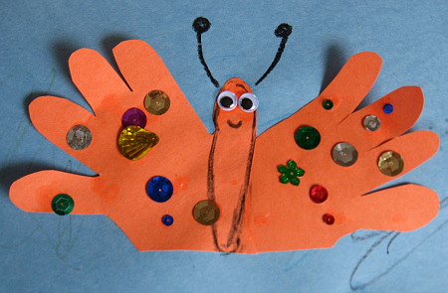
Make your own hungry caterpillar/ butterfly using materials you have at home
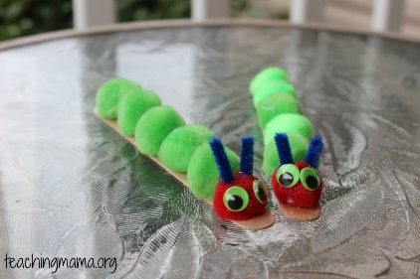
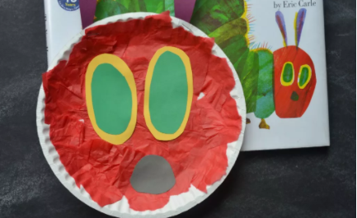
Story: The Very Hungry Caterpillar
The Very Hungry Caterpillar - Animated Film - YouTube

Cosmic Kids Yoga: The Very Hungry Caterpillar
The Very Hungry Caterpillar | A Cosmic Kids Yoga Adventure! - YouTube

Sensory play: Make some chocolate play dough (flour, salt, warm water and cocoa powder)
Have fun making and decorating some heart biscuits to celebrate Valentine’s Day.

Types of play: Imaginary: This is important for children as it helps to develop their language, social skills, and ability to use their imagination. This could be done through acting out stories, role play such as kitchen/home, baby dolls or animals.
Fine motor skills: We do lots of fine motor practice in pre-school. It is particularly important to strengthen the children’s muscles in their hands. This can be done in many ways:
Play dough – rolling and squeezing
Scissor skills practice
Threading beads or something similar
Puzzles
Lego/block play

