Reception Newsletter

Monday 22nd March 2021

Learning

This week we will be starting our ditty writing books and focusing on writing sentences. We will also be starting to learn some set 3 sounds. Some set 3 sounds we call chatty friendsbecause we have to split them up,with another letter between them. 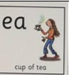 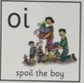

In maths this week, we will be describing 3d shapes by naming their properties vertices, edges, faces.

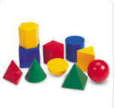

PLEASE read at home as often as possible but at least 3 or 4 times a week**.** C:\Users\ciaramoran\AppData\Local\Microsoft\Windows\Temporary Internet Files\Content.IE5\5JV43MRH\MC900440424[1].wmf

Optional Home Work.

It is always beneficial to read with your child 3 times per week.

Have a look at your little yellow book. Can you name all the sounds?

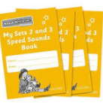Outside is fantastic for mark making and practising forming the numbers from 10-20. You could use stones, sticks, leaves etc..

Easter is nearly upon us and we will be busy celebrating Easter, making Easter cards and crafts.

Diary dates

01/04/2021 End of half term - children finish at normal time

19/04/2021 Children return to school - start of Summer term

03/05/2021 May Bank Holiday

28/05/2021 End of half term - children finish at normal time

07/06/2021 Children return to school - start of Summer 2 half term

Star Celebrations: All the children have been stars but we would particularly like to say well done to Hollie for her concentration and commitment in forming her letters correctly and to Emilia for her concentration in maths and learning 1 more than a given number.

.                

**Reminders:**

Please visit the classroom blog I do try to update it weekly.

PE on Tuesday- please can the children come to school in their PE Kit?

Fun Fit -Friday

Drinking bottles should be **filled with water**. If your child has a medical issue, we are happy to discuss this further.