Reception Newsletter

Monday 29th March 2021

Learning

This week we will be learning to sound, write and spell with the letter sounds i-e, ay and o-e. Please complete them in the little green RWI book.

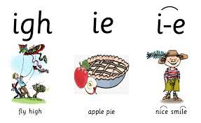 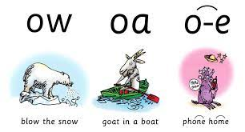 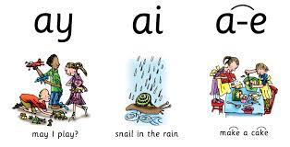

In maths this week we will be doubling, halving and sharing numbers. We will be using our problem solving skills and will be writing number sums.

The children’s topic question is; How does your garden grow? We will be looking at how things grow such as plants, life cycles and weather.

Reading

As part of our phonics, we are now listening to the children read through ditty time in addition to their individual reading. This means that we may only listen to children read their home books once per week, but we will do our best to hear the children to read as often as possible.

Optional Home Work.

Please continue to read with your child at home daily.

Please continue to practise letter formation at home. You might want to do this through finger paint, in sand/foam or a simple pencil ad paper. Your child can also log into mathletics to complete activities on there.

Parent Consultations

Parent consultations will be held on Thursday 22nd and Friday 23rd April. Please come and see us so that we can get you booked in.

**Reminders:**

PE is every Tuesday, please can children come to school in their PE kits. Please can you ensure that your child’s clothes are labelled as this way we can help, return them. However it is your child’s responsibility to look after their uniform.

Diary dates

01/04/2021 End of half term - children finish at normal time

19/04/2021 Children return to school - start of Summer term

03/05/2021 May Bank Holiday

28/05/2021 End of half term - children finish at normal time

07/06/2021 Children return to school - start of Summer 2 half term

11/06/2021 Inset Day

23/07/2021 End of school year - children finish at normal time

Star Celebrations: This week we would like to celebrate Archie B and Finlay for their learning achivements.

              