Reception Newsletter

Monday 26th April 2021

Learning

This week we will be learning to sound, write and spell with the letter sounds ai, ar and er. Please complete them in the little green RWI book.

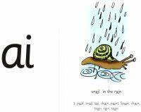 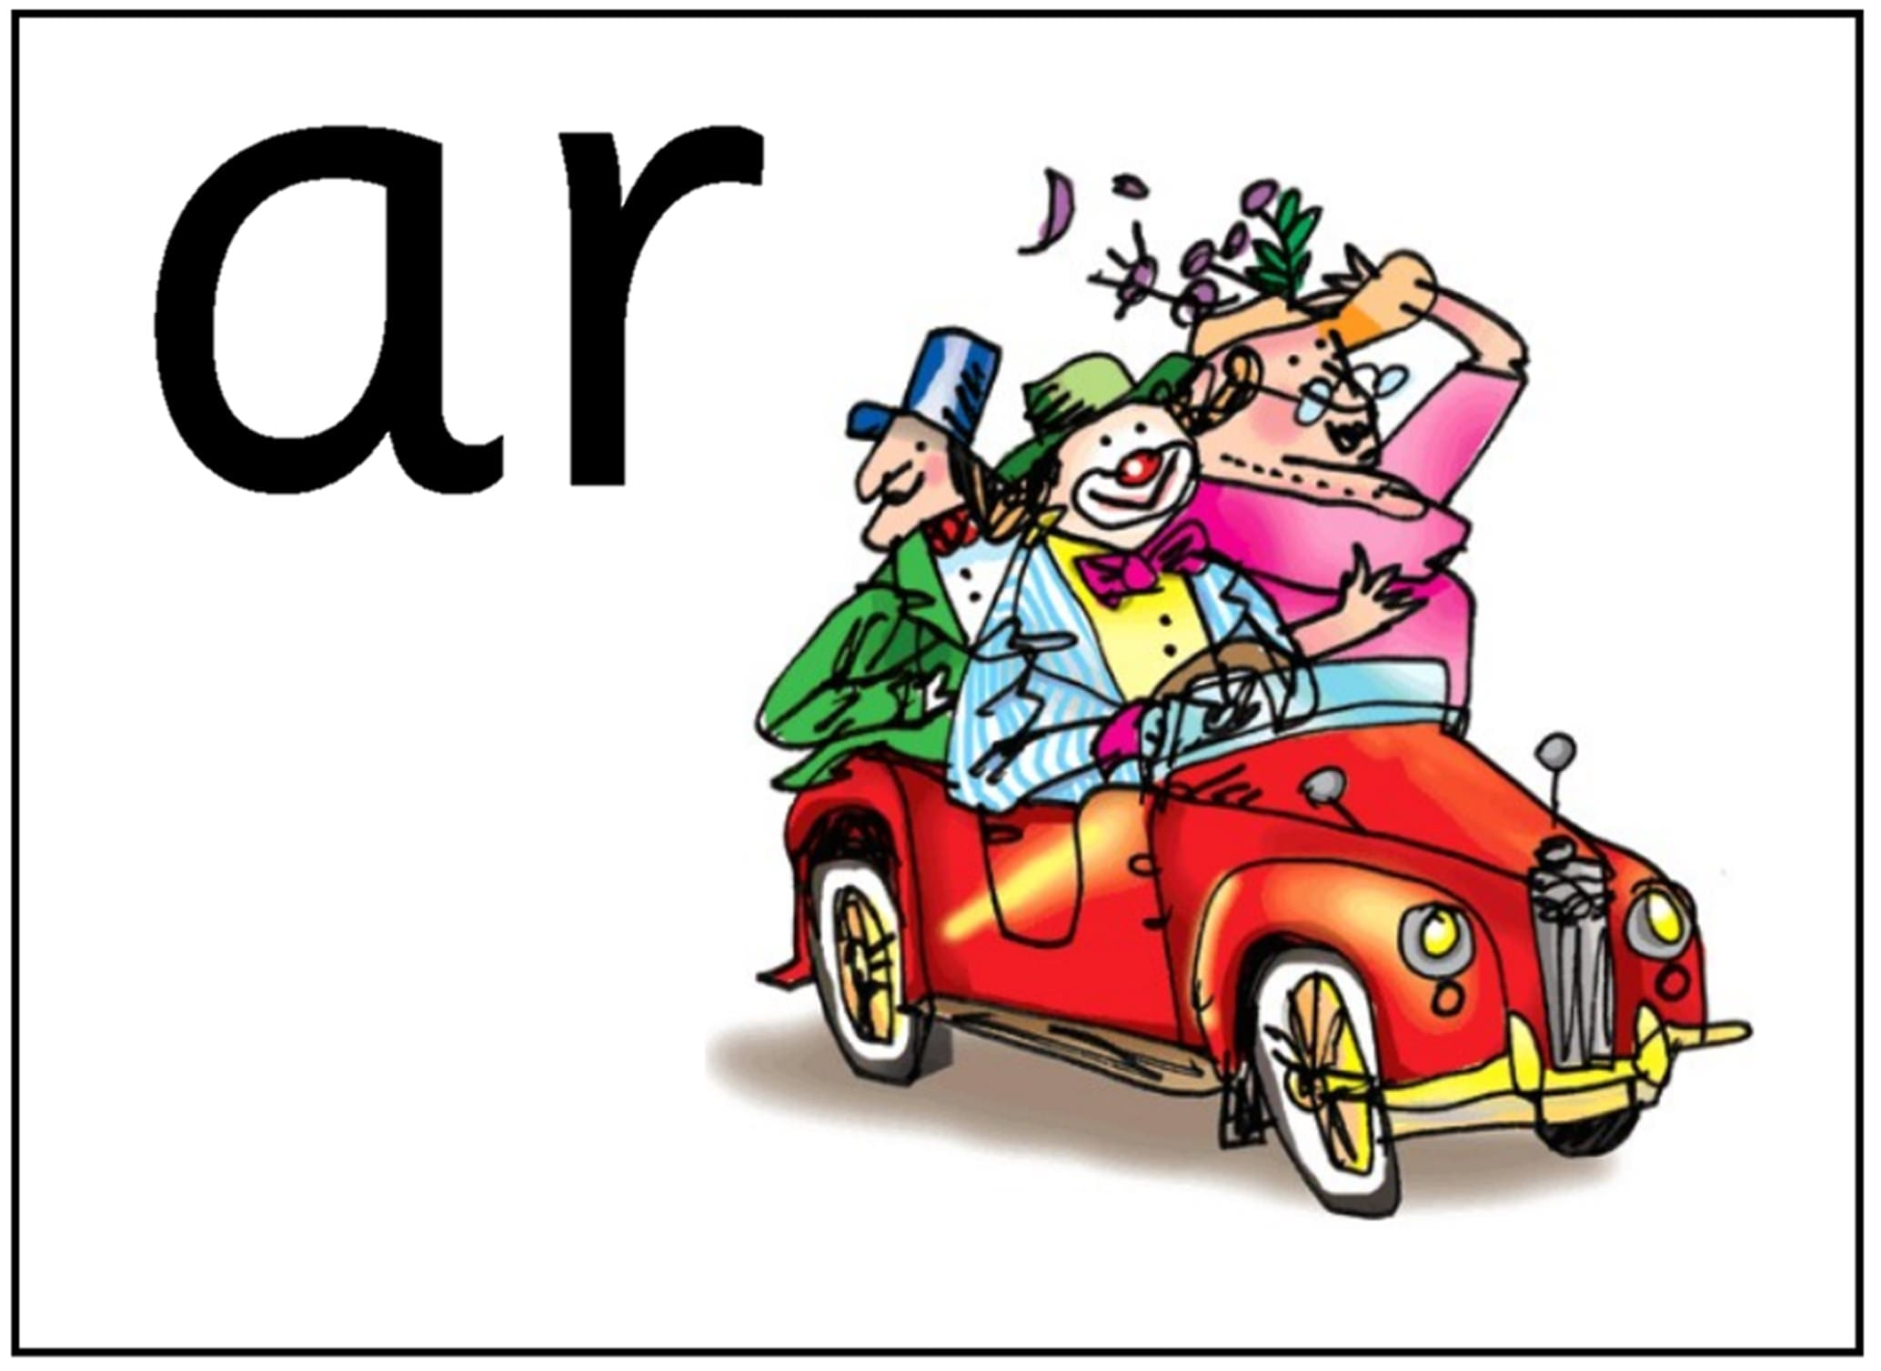 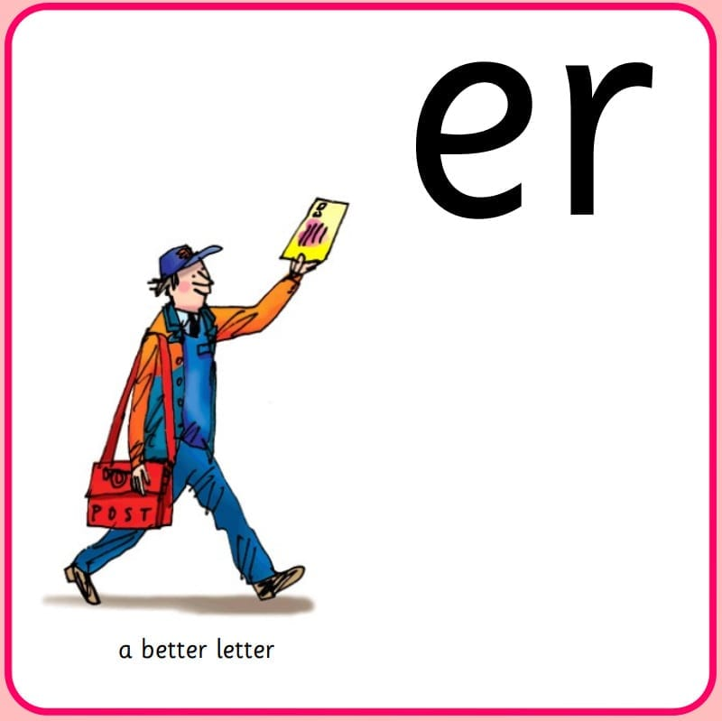

In maths this week we will be looking at adding and subtracting. We will be using number lines to count forward and backwards to solve addition and subtraction number stories. We will also be using ‘first, then and now’ to learn how to write number sentences.

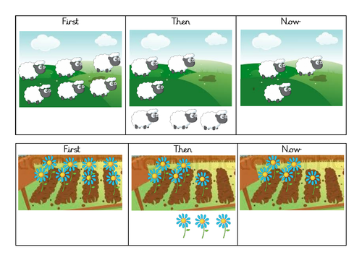

Optional Home Work.

Please continue to read with your child at home daily.

Diary dates

We will be ready to welcome them back on the 19th April for the start of the summer term.

01/04/2021 End of half term - children finish at normal time

19/04/2021 Children return to school - start of Summer term

03/05/2021 May Bank Holiday

28/05/2021 End of half term - children finish at normal time07/06/2021 Children return to school - start of Summer 2 half term.

11/06/2021 Inset Day

23/07/2021 End of school year - children finish at normal time

Star Celebrations: This week we would like to celebrate Emilia and William for their learning achivements.

              

Warmer Weather

Now that the weather is starting to get warmer can you please make sure that your child brings a sunhat and sun cream to school.

**Reminders:**

PE is every Tuesday, please can children come to school in their PE kits. Please can you ensure that your child’s clothes are labelled as this way we can help, return them. However it is your child’s responsibility to look after their uniform.