Reception Newsletter

Monday 24th May 2021

Learning

This week we will be learning to sound, write and spell with the letter sounds i-e, o-e and igh. Please complete them in the little green RWI book.

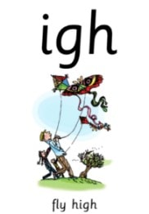[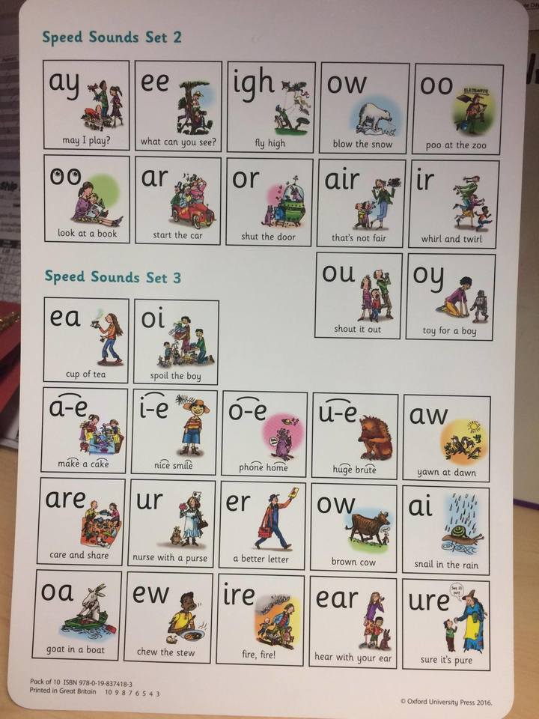](http://www.google.co.uk/url?sa=i&rct=j&q=&esrc=s&source=images&cd=&cad=rja&uact=8&ved=2ahUKEwjflcfDwObhAhWOlxQKHZqeDqoQjRx6BAgBEAU&url=http://www.bewseylodge.co.uk/learn_more/curriculum/read_write_inc_/&psig=AOvVaw1zGE5RhABvA-PNXgnWQB_6&ust=1556118806474036)

In maths this week we will be focusing on measuring length, height and capacity. We will be discussing lots of vocabulary around measuring and will be ordering and comparing measures.

To support maths, you could practise measuring at home. “Can you order your teddies in height order”, “Who is the tallest person in this house?”, “Can you put some water in the cup so that it is half full?”

Optional Home Work

Please continue to read with your child at home daily.

How does your garden grow?

For topic homework, could the children go on a tree hunt. How many types of different trees can they spot? What are their characteristics. We would love to see a picture or painting of any trees that you find.

Egg Race

A big thank you to everyone who has sponsored us for our egg and spoon race.

Football Club

Can the children who are taking part in football club please come to school in their kit.

Diary dates

24th May –Sponsored welly throw.

28/05/2021 End of half term - children finish at normal time

07/06/2021 Children return to school - start of Summer 2 half term.

11/06/2021 Inset Day

23/07/2021 End of school year - children finish at normal time

Warmer Weather

Now that the weather is starting to get warmer can you please make sure that your child has sun cream applied and brings a sunhat to school.

**Reminders:**

Football on Thursday after school 3.30-4.30

PE is every Tuesday, please can children come to school in their PE kits. Please can you ensure that your child’s clothes are labelled as this way we can help, return them.

Fun fit Friday continues throughout this term.

Star Celebrations: This week we would like to celebrate Rose, Maverick and Willow for their learning achivements.

              