Reception Newsletter

Monday 7th June 2021

Learning

This week we will be learning to sound, write and spell with the letter sounds aw, oo and u-e. Please complete them in the little green RWI book.

[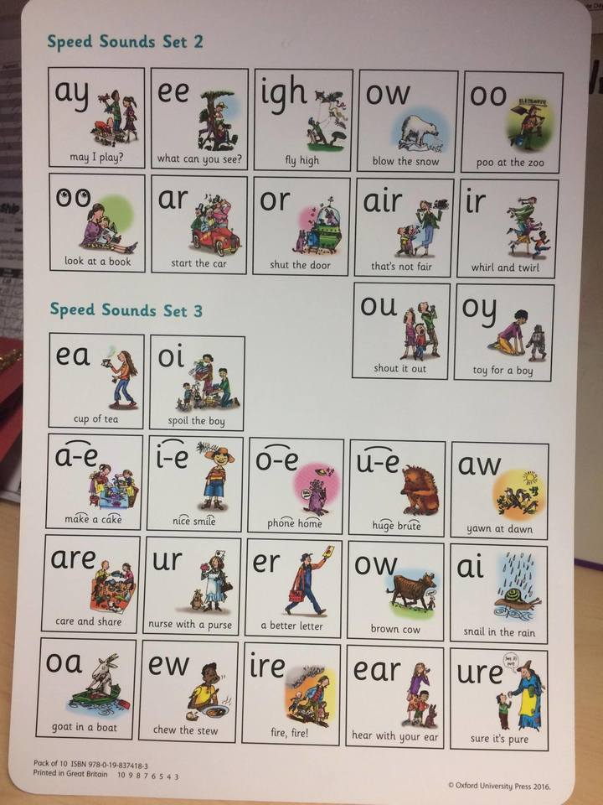](http://www.google.co.uk/url?sa=i&rct=j&q=&esrc=s&source=images&cd=&cad=rja&uact=8&ved=2ahUKEwjflcfDwObhAhWOlxQKHZqeDqoQjRx6BAgBEAU&url=http://www.bewseylodge.co.uk/learn_more/curriculum/read_write_inc_/&psig=AOvVaw1zGE5RhABvA-PNXgnWQB_6&ust=1556118806474036)  [](http://www.google.co.uk/url?sa=i&rct=j&q=&esrc=s&source=images&cd=&cad=rja&uact=8&ved=2ahUKEwjflcfDwObhAhWOlxQKHZqeDqoQjRx6BAgBEAU&url=http://www.bewseylodge.co.uk/learn_more/curriculum/read_write_inc_/&psig=AOvVaw1zGE5RhABvA-PNXgnWQB_6&ust=1556118806474036)

Please continue to read with your child at home daily.

Optional Home Work

How does your garden grow?

For topic homework, could the children have a look in their garden and take a photo of something that they like. They could also write a sentence about what they like.

Wearing Yellow

On Friday 18th June can your child please come to school wearing something yellow. This could be a top or leggings. This is to show our support for cystic fibrosis.

Diary dates

07/06/2021 Children return to school - start of Summer 2 half term.

11/06/2021 Inset Day

18/06/2021 Children to wear yellow

23/07/2021 End of school year - children finish at normal time

Warmer Weather

Now that the weather is starting to get warmer can you please make sure that your child has sun cream applied and brings a sunhat to school.

**Reminders:**

PE is every Tuesday, please can children come to school in their PE kits. Please can you ensure that your child’s clothes are labelled as this way we can help, return them.

Fun fit Friday continues throughout this term.

Star Celebrations: This week we would like to celebrate Emily and Eliot for their learning achivements.

              