4/5 Challenges Over Summer 2021

What a year we’ve had! It’s time for everyone to get a well-deserved break. Over the summer, we have come up with some learning challenges for Years 4 and 5 if you want to. Good luck!

Times Tables
Children can go onto Times Table Rockstars or ‘hit the button’ to practice their times tables. How many questions can you get right in a minute?

Websites:
https://www.topmarks.co.uk/maths-games/hit-the-button
https://ttrockstars.com

Spellings
Can you get all your 5/6 spellings right without looking?

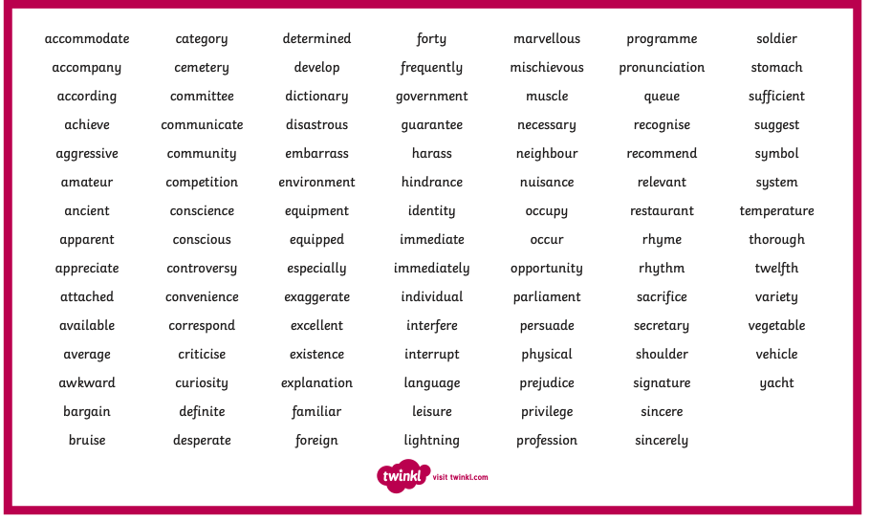

Writing
There will be a writing competition over the summer holidays. This could be a story, diary entry, letter, non-fiction piece or something else – be creative! The only challenge is that it must be less than 1,000 words (roughly 2 A4 pages long). There will be prizes for the best pieces of writing!

Websites:
https://www.pobble365.com
https://www.talk4writing.com/home-school-units/

