Reception Newsletter

Monday 20th September 2021

Home Work.

It is always beneficial to read with your child 3 times per week. Please can you ensure that you record reading in your child’s reading record book so that we can monitor how often they are reading.

Please continue to practise reading by sight the tricky red words in the red word bags. These really do help with the fluency of reading. Perhaps hide them around the house / play red word bingo/ turn the card over or use a timer to see how quick you can read them.

Could you find and post 1 interesting fact about Sir Tom Moore on Tapestry?



Learning

This week we will be learning the new sound ‘a’ and finding lots of things that begin with this sound.

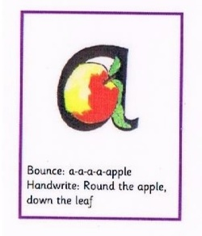Around the apple and down the leaf.

In maths this week we will be looking at the number 1. We will also start sorting objects according to their properties.



Vipers book mark. This explains a little more in depth the reading skills we as a school promote and encourage. We will make and laminate a book mark at school to send home this week.

Star Celebrations: All the children have been stars but this week we would like to celebrate the achievements of Ezra T and Spencer. Please see the assembly link that Mrs. Spencer will send out weekly for assemblies.

              

Diary dates

Half term- 18th October

Inset Day – Monday 1st November School Returns-

Tuesday 2nd November.

**Reminders:**

Please note that Breakfast Club and After School Club, (due to Covid) now have restricted places. Please can you ensure that you have booked your child’s place with the School Secretary in advance.

We are taking part in the Government baseline. <https://www.gov.uk/government/publications/reception-baseline-assessment-information-for-parents>