R/1C Newsletter (Reception)

Monday 27th September 2021

Optional Home Work.

It is always beneficial to read with your child 3 times per week.

Try to practise writing this week’s letter sounds. Can your child find any objects that begin with this sound? Can your child write it? This could be with paint, in the sand, in the mud!

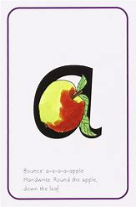

If anyone else is collecting your child, please let us know in the morning.

Green home books

You may have noticed some green books in your child’s book bag this week. These books are for home use and are a great way for your child to practise writing letters.

This week

Learning through play

We have had another busy week learning through play. The children have had great fun practising their balancing skills on balancing bikes and have been practising writing the letter ‘m’ in a range of different ways. They have also enjoyed the minibeast discovery tray and water play!

Maths

We have been learning how to match, pair and compare a range of objects! To support this you could play a game of ‘pairs’ at home or help to oragnise objects into shape, size or colour.

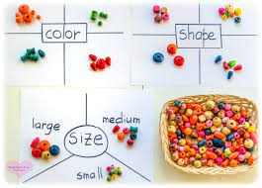

We would love to see your children’s work on tapestry!

Diary dates

Half term- 25th October

Inset Day – Monday 1st November

School Returns- Tuesday 2nd November.

Every Friday – Fun Fit Friday, please send your children to school in sportswear and trainers.

.

**Reminders:**

Staff names

Mrs Campbell – Teacher (Monday, Tuesday, Wednesday)

Mrs Chapman – Teacher (Thursday/Friday)

Miss Ward – Teaching Assistant

Miss Treleaven – Teaching Assistant

Parent Consultations

If you haven’t done so already please book your parent consultations through Arbor.