Reception Newsletter

Friday 3rd December 2021

Optional Home Work.

It is always beneficial to read with your child 3 times per week. Red words help with the fluency of reading.

At talk time, we would really love you to use some of the following words with your child.

|  |  |
| --- | --- |
|  | |
| after | man | |
| back | year | |
| little | came | |
| only | show | |
| round | every | |

Please practice reading your Red Words at home by sight. We often play find the red word or matching pair games.

Thank you.

This week

MathsThis week we will be learning more about the number 4. How many ways can we make 4? Can we count backwards and forwards from 4? How many 4 sided shapes can we name?

Phonics The children have been learning the new sounds ‘ng’ ‘nk’ and over the course of the next few weeks we are going to ensure that we are working towards being secure with our set 1 sounds and blending words.

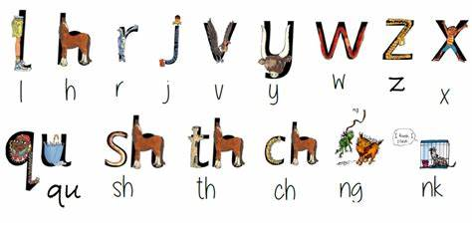 

You may like to make a list of words which contain these sounds.

Christmas Natvity – has begun and we have started practising our parts in the Wriggly Nativity. If your child has lines to read we will send these home shortly.

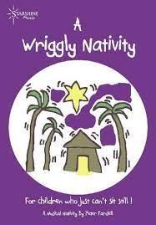 

Dates

3rd Dec-Elf Day - for Alzheimer's Society Come as an elf today and join in with 'elfie' workouts and have an 'elfie' taken. Suggested 50p donation and 20p for photos.

10th Dec- Christmas Dinner and Christmas Jumper Day £1 in aid of Save the Children.

Thursday 16th December- Reception Nativity Performance at 1.30 in the Hall.

Every Monday -PE

Every Friday – Fun Fit Friday.

**Reminders:**

You should have all received information on the part your child is in the Nativity. If you have not please let a member of staff know.

Christmas is nearing and we are on the hunt for as many **card board /kitchen roll** tubes as possible. Thank you for your support.

Lunches are now booked via Parent Pay.