Reception Newsletter

Friday 7th January 2022

Optional Home Work.



This week we would really like your support in ensuring that as many of the children as possible are secure on their set 1 sounds. These can be found at the back of the little green phonics books that the children write their letter sounds in.

During conversations, we would really love you to use some of the following words with your child.

Same mean too Does

Differ move Old

Right boy tell

Thank you.

Thank you.

This week

We all hope you've had a lovely Christmas and New Year and are feeling refreshed for the new term. Our question this half term is, ‘Does the whole world have a winter wonderland? We have been considering how the inuit people keep warm and looking at other ways to keep warm.

Maths

We have been working with the numbers from 1-5 , counting backwards and looking at zero.

Phonics We have been using this week to help secure our set 1 sounds. We have revised these sounds.

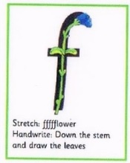  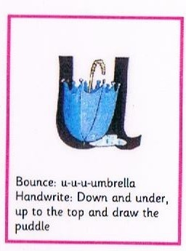 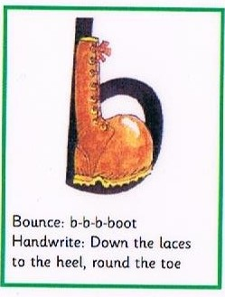

**Reminders:**

We would like to give a big welcome to Mrs Brown who joins us full time. Mrs Brown has a wealth of experience working with children and we welcome her fresh ideas.

Mr Goodeve will no longer be working in Reception. year 2 have the benefit of his skills and experience. He will be greatly missed.

Dates

7th February- Parenting course open to all parents. Perfect for those who want some guidance on sleeping/routine/eating and general parenting concerns. If you are interested in this then let a member of staff know and we can sign you up.

18th February- Last day of term.

28th February- Inset Day

1st March – Welcome children back to school

Every Monday- PE

Every Friday- Fun Fit Friday.